**DRIVING SCHOOL**

**MANAGEMENT**

**SYSTEM**

***DONE BY:-***

***LUKKA SHIVA CHARAN***

***IT B***

***1602-19-737-103***

**1**

**ABSTRACT:**

The Driving School Management System is a web- based system that provides a single-stop for registration and maintenance of driving school database of Cherry Driving School (Name of driving school). The database consists of all the details of customer, details of staff allotted to a particular customer, registration status, payment with license or without license, vehicle number and number of class the customer has opted for. We provide online as well as offline registrations whereas classes are not virtual, there will be people who will approach at your specified address and pick you up and train you on a kilometer basis for one particular day. Driving School Management System (DSMS) is important for ensuring the correct operation of driving school and in maintaining the services that run on them. This project has total of 6 tables. It describes how the network is being connected all across the customers and the particular staff. When you enter the data, it is stored in the data base and is displayed whenever you need it. The data can be updated or changed only by the people of the driving school.

**2**

**REQUIREMENT ANALYSIS:**

List of tables:

* Customer_details
* Vehicle_time
* Further_details
* Staff_details
* Id_proofs & postal
* Payment_status

List of attributes with their domain types:

1.Customer_details:

Cust_Id: cust_id number (5)

C_name: C_name varchar2 (20)

Date of join: date of join varchar2 (20)

Licence_type: licence_type varchar2 (20)

Mobile_num: Mobile_num number(20)

Email_id: email_id varchar2 (20)

Address: Address varchar2 (20)

**3**

2.Vehicle_time:

Cust_name: cust_name varchar2(20)

Period: period varchar2(15)

Time of attending: time of attending varchar2 (20)

Vehcile_type: vehicle_type varchar2 (20)

Vehcile name: vehicle name varchar2 (20)

3.Further details:

Customer_id: customer_id number (5)

Course days: course days number (2)

Licence_required: Licence_required varchar2 (20)

Pickup Address: pickup address varchar2 (20)

4.Staff details:

Staff_id: staff_id number (5)

Person_Name: Person_name varchar2 (20)

Mobile_number: mobile_number number (15)

Email: email varchar2 (30)

Staff_add: Staff_add varchar2 (30)

5.Id_proofs& postal:

Person_id: Person_id number (5)

Name: name varchar2 (20)

Aadhar No: aadhar number (16)

Tenth_memo: tenth memo varchar (20)

Postal_Address: postal address varchar2 (20) **4**

6. Payment Status:

id: id number (5)

Customer_Name: customer_name varchar2 (20)

Total Money: total money number (5);

Money Paid: money paid number (5);

**5**

**MAPPING CARDINALITY AND PARTICIATION**

* **CONSTRAINTS**

The internet is connected to server. So, every servers connected to the internet, which is one to many participations. In this you can only opt for a one particular vehicle type at a time and the time of attending to driving classes cannot be changed once you are done with filling the form. You will be allotted one staff member who will pick you and drop you depending upon the pickup location. Your Id proofs are must in order to opt for a driving licence. You will receive licence only when your payment is completely done. For the driving registration you have two means i.e online and offline. Each computer will have only one operating system which is one to one participation.

**6**

ARCHITECTURE AND TECHNOLOGY

*Software used:*

Java Eclipse, Oracle 11g Database,Java SE version 13, SQL*Plus.Java

**AWT:**

Java AWT (Abstract Window Toolkit) is an API to develop GUI or window-based applications in java.Java AWT components are platform-dependent i.e. components are displayed according to the view of operating system. AWT is heavyweight i.e. its components are using the resources of OS.The java.awt package provides classes for AWT API such as TextField, Label, TextArea,RadioButton, CheckBox, Choice, List etc.

**SQL:**Structure Query Language(SQL) is a database query language used for storing and managing data in Relational DBMS. SQL was the first commercial language introduced for E.F Codd's Relational model of database. Today almost all RDBMS (MySql, Oracle, Infomix, Sybase, MS Access) use SQL as the standard database query language. SQL is used to perform all types of data operations in RDBMS.

**7**

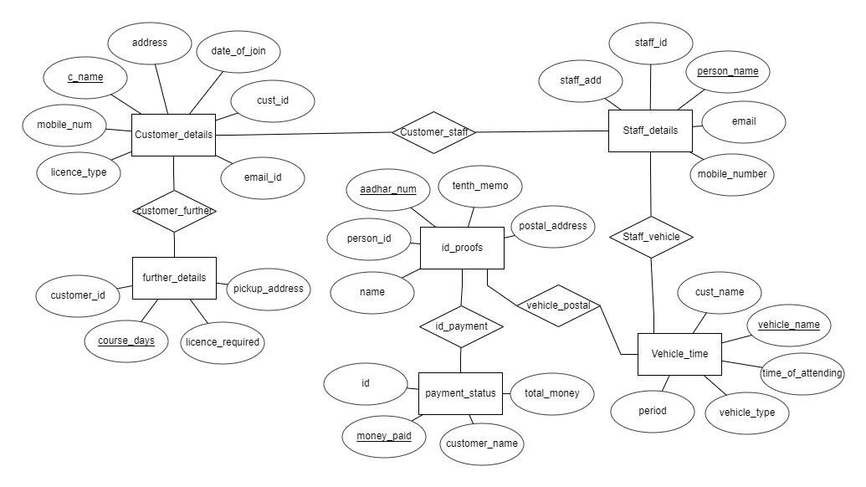

**8**

**DDL COMMANDS:**

1. create table **customer_details** (cust_id number (5), c_name varchar2(20) primary key, date_of_join varchar2(20), mobile_num number (20), email_id varchar2(30), address varchar2(30));
2. create table **vehicle_time** (cust_name varchar2(20), period varchar (15), time_of_attending varchar2(30), vehicle_type varchar2(20), vehicle_name varchar2(20) primary key);
3. create table **further_details** (customer_id number (5), course_days number (2) primary key, licence_required varchar2(20), pickup_address varchar2(30));
4. create table **staff_details** (staff_id number (5), person_name varchar2(20) primary key, mobile_number number (15), email varchar2(30), staff_add varchar2(30));
5. create table **id proofs** (person_id number (5), name varchar2(20), aadhar_num number (16) primary key, tenth_memo varchar2(20), postal_address varchar2(30));
6. create table **payment_status** (id number (5), customer_name varchar2(20), total_money number (5), money_paid number (5) primary key);
7. create table **customer_staff**(c_name varchar2(20), person_name varchar2(20), foreign key(c_name) references customer_details(c_name), foreign key(person_name) references staff_details(person_name));
8. create table **staff_vehicle** (person_name varchar2(20), vehicle_name varchar2(20), foreign key(person_name) references staff_details(person_name), foreign key(vehicle_name) references vehicle_time(vehicle_name));
9. create table **vehicle_postal** (vehicle_name varchar2(20), aadhar_num number (16), foreign key(vehicle_name) references vehicle_time(vehicle_name), foreign key(aadhar_num)

**9**

references id_proofs(aadhar_num));

1. create table **id_payment** (aadhar_num number (16), money_paid number (5), foreign key(aadhar_num) references id_proofs(aadhar_num), foreign key(money_paid) references payment_status(money_paid));
2. create table **customer_further** (c_name varchar2(20), course_days number (2), foreign key(c_name) references customer_details(c_name), foreign key(course_days) references further_details(course_days));

DML COMMANDS

1. insert into customer_details values(&cust_id,'&c_name','&date_of_join','licence_type',&mobile_num,'&email_id','&address');
2. insert into staff_details values(&staff_id,'&person_name',&mobile_number,'&email','&staff_add');
3. insert into vehicle_time values('&cust_name','&period','&time_of_attending','&vehicle_type','&vehicle_name');
4. insert into id_proofs values(&person_id, ‘person_name', &aadhar_num, '&tenth_memo', '&postal_addess');
5. insert into payment_status values (&id, '&customer_name', &total_money, &money_paid);
6. insert into further_details values (&customer id, &course_days, '&licence_required', '&pickup_address');

**10**

**OUTPUTS:**

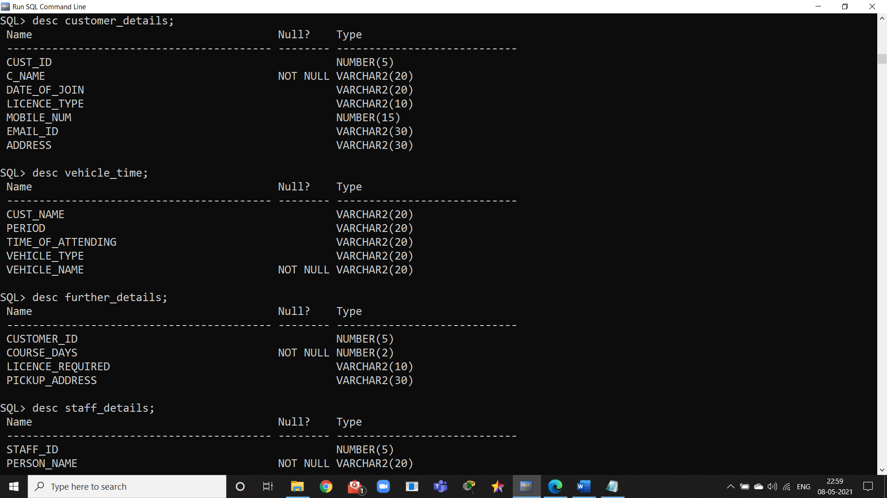

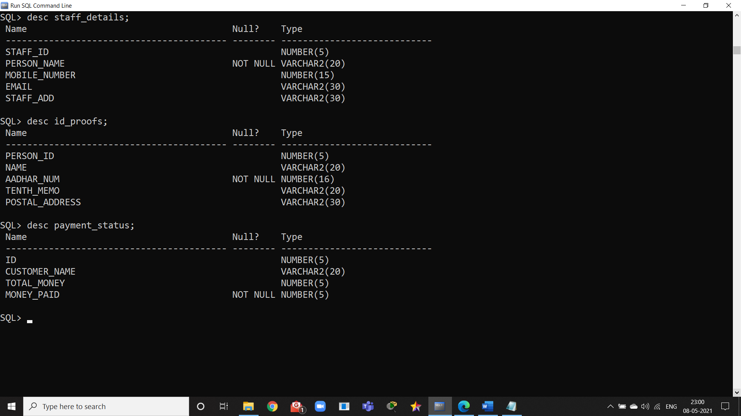

**11**

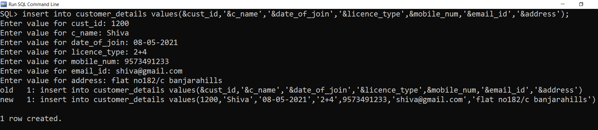

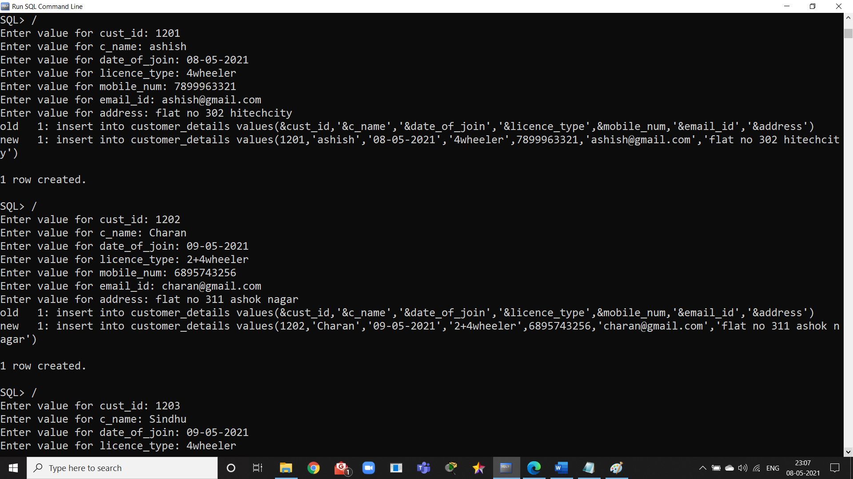

**12**

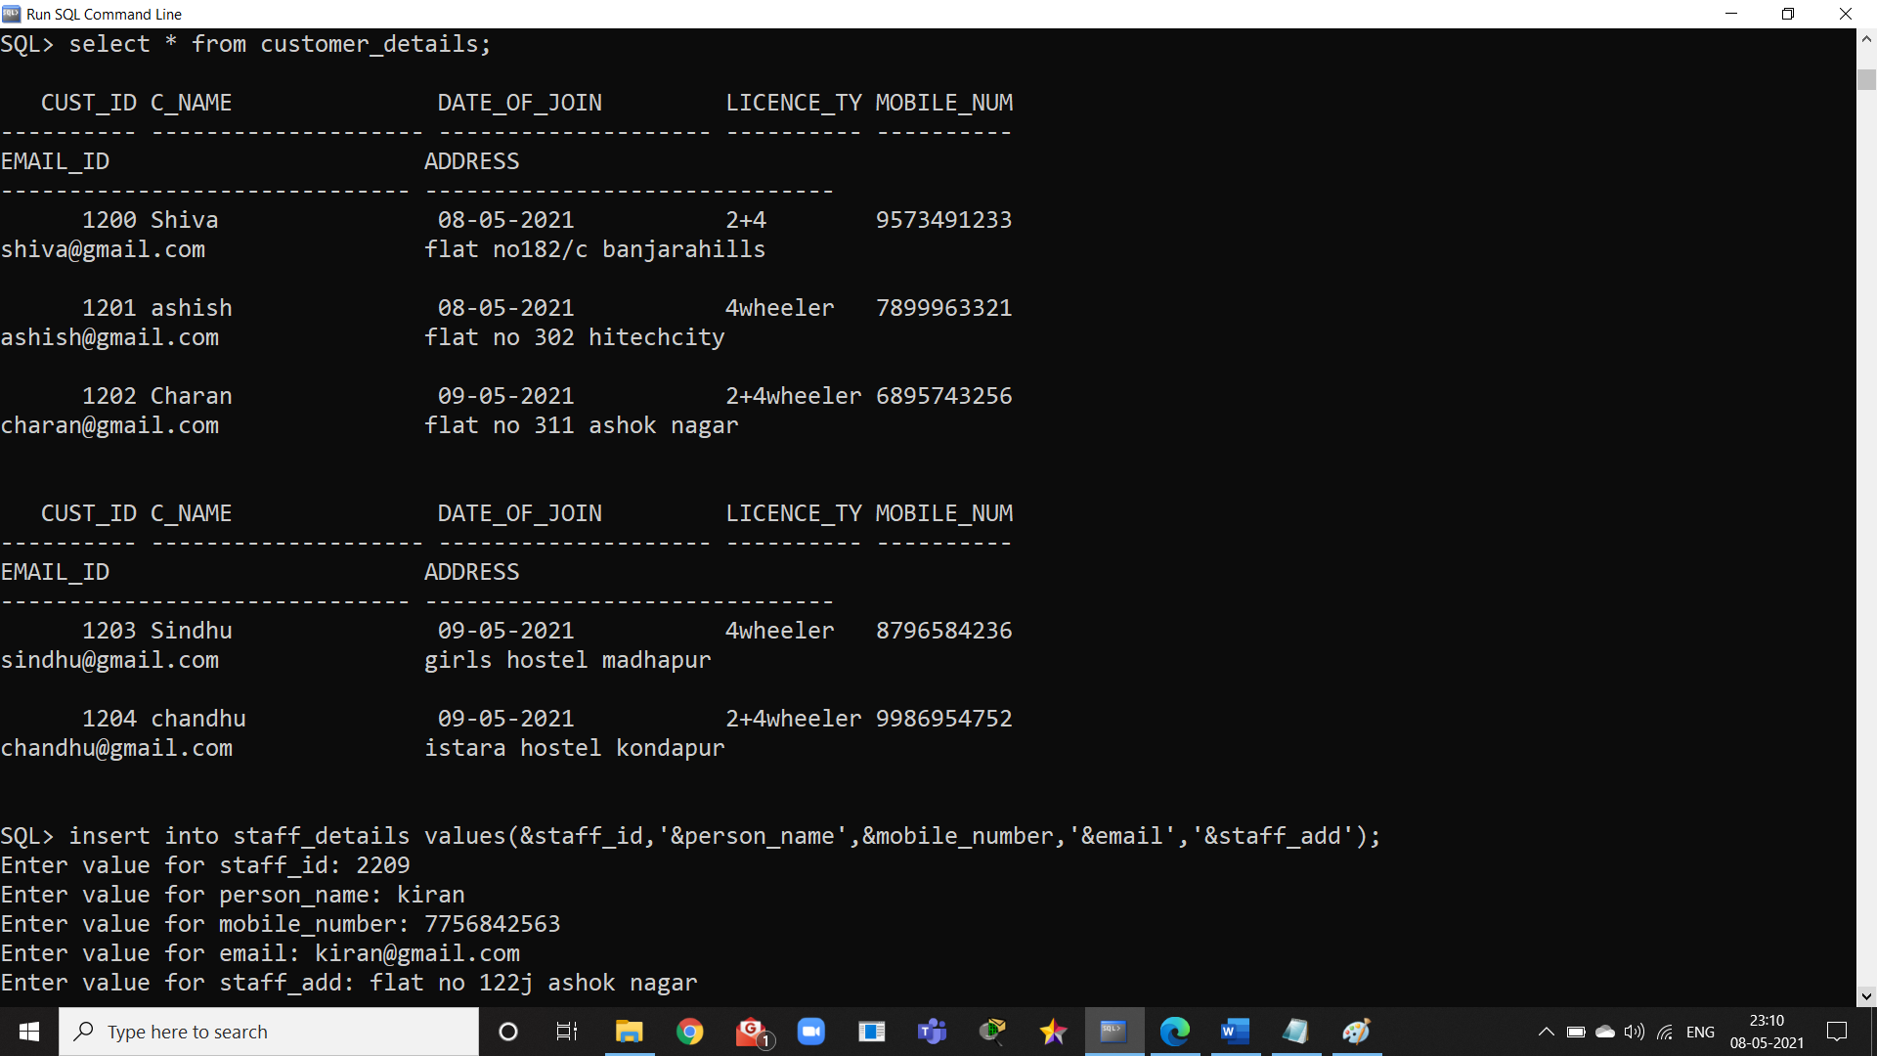

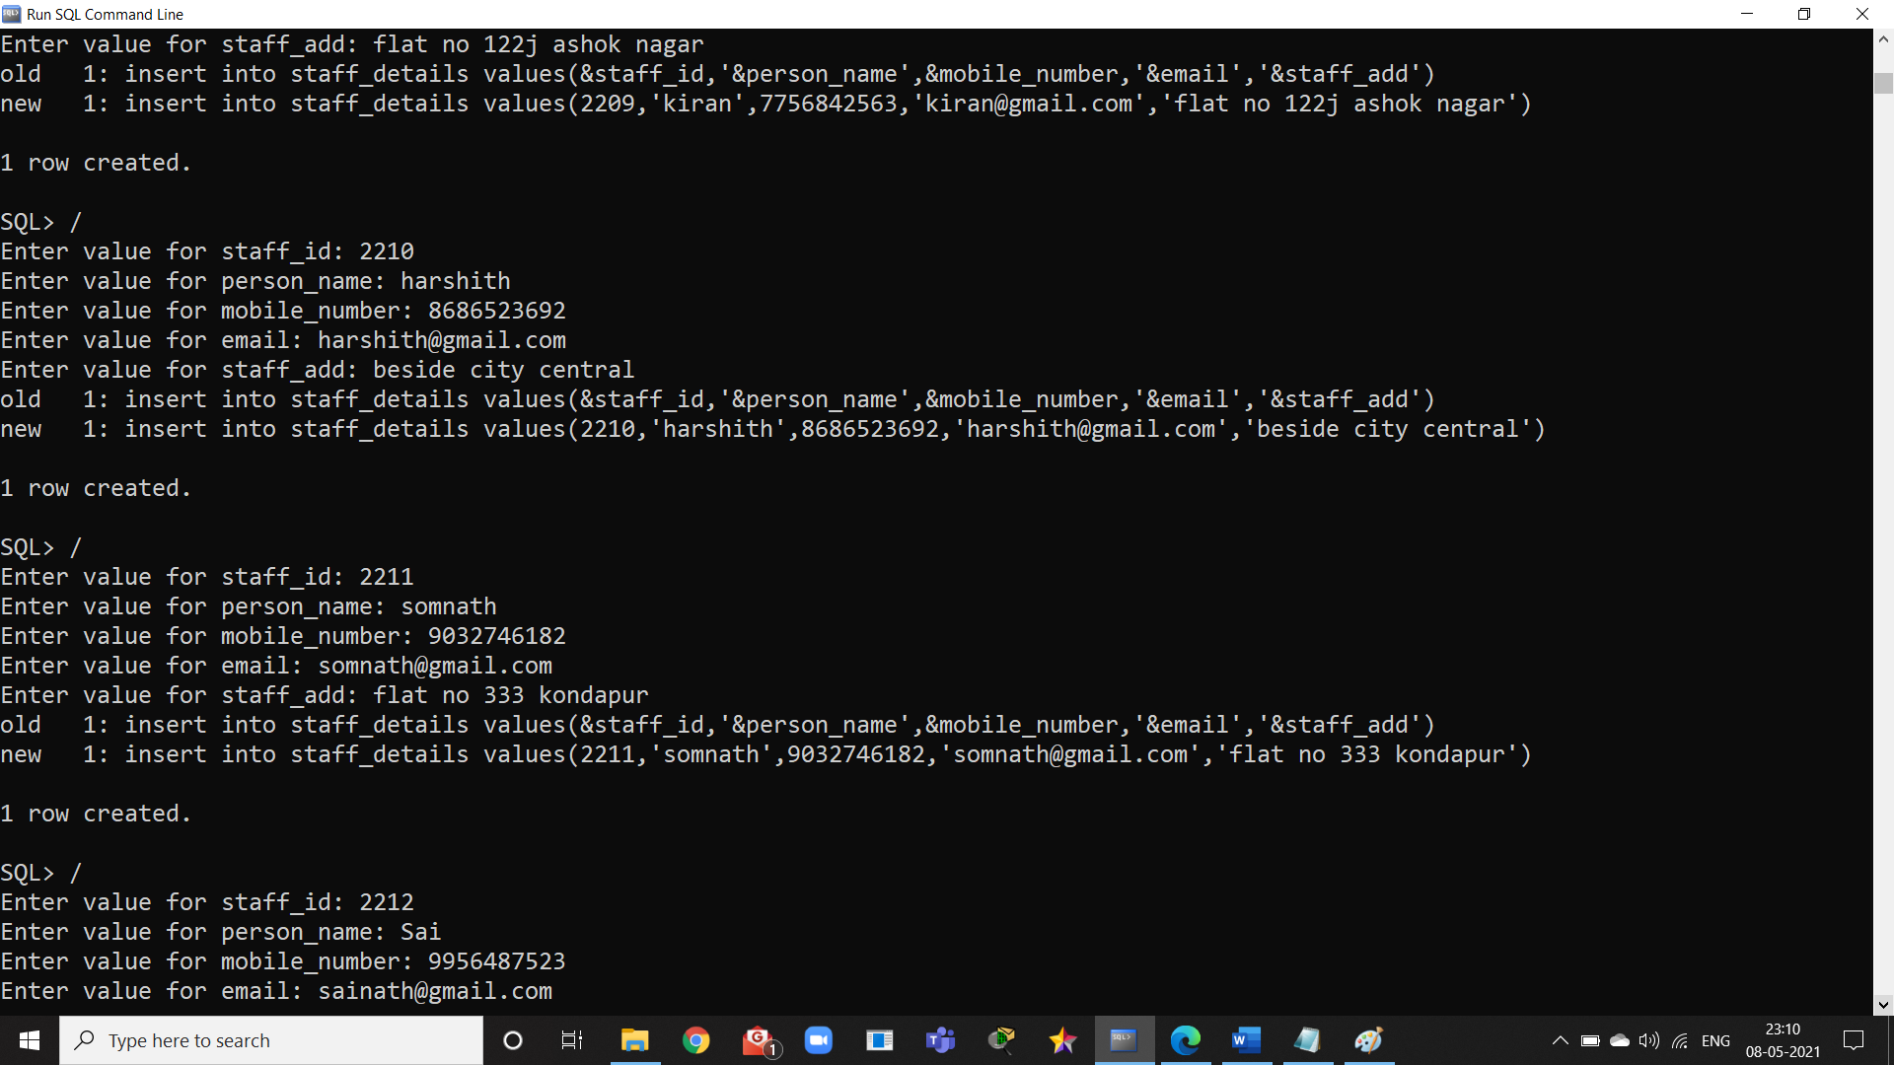

**13**

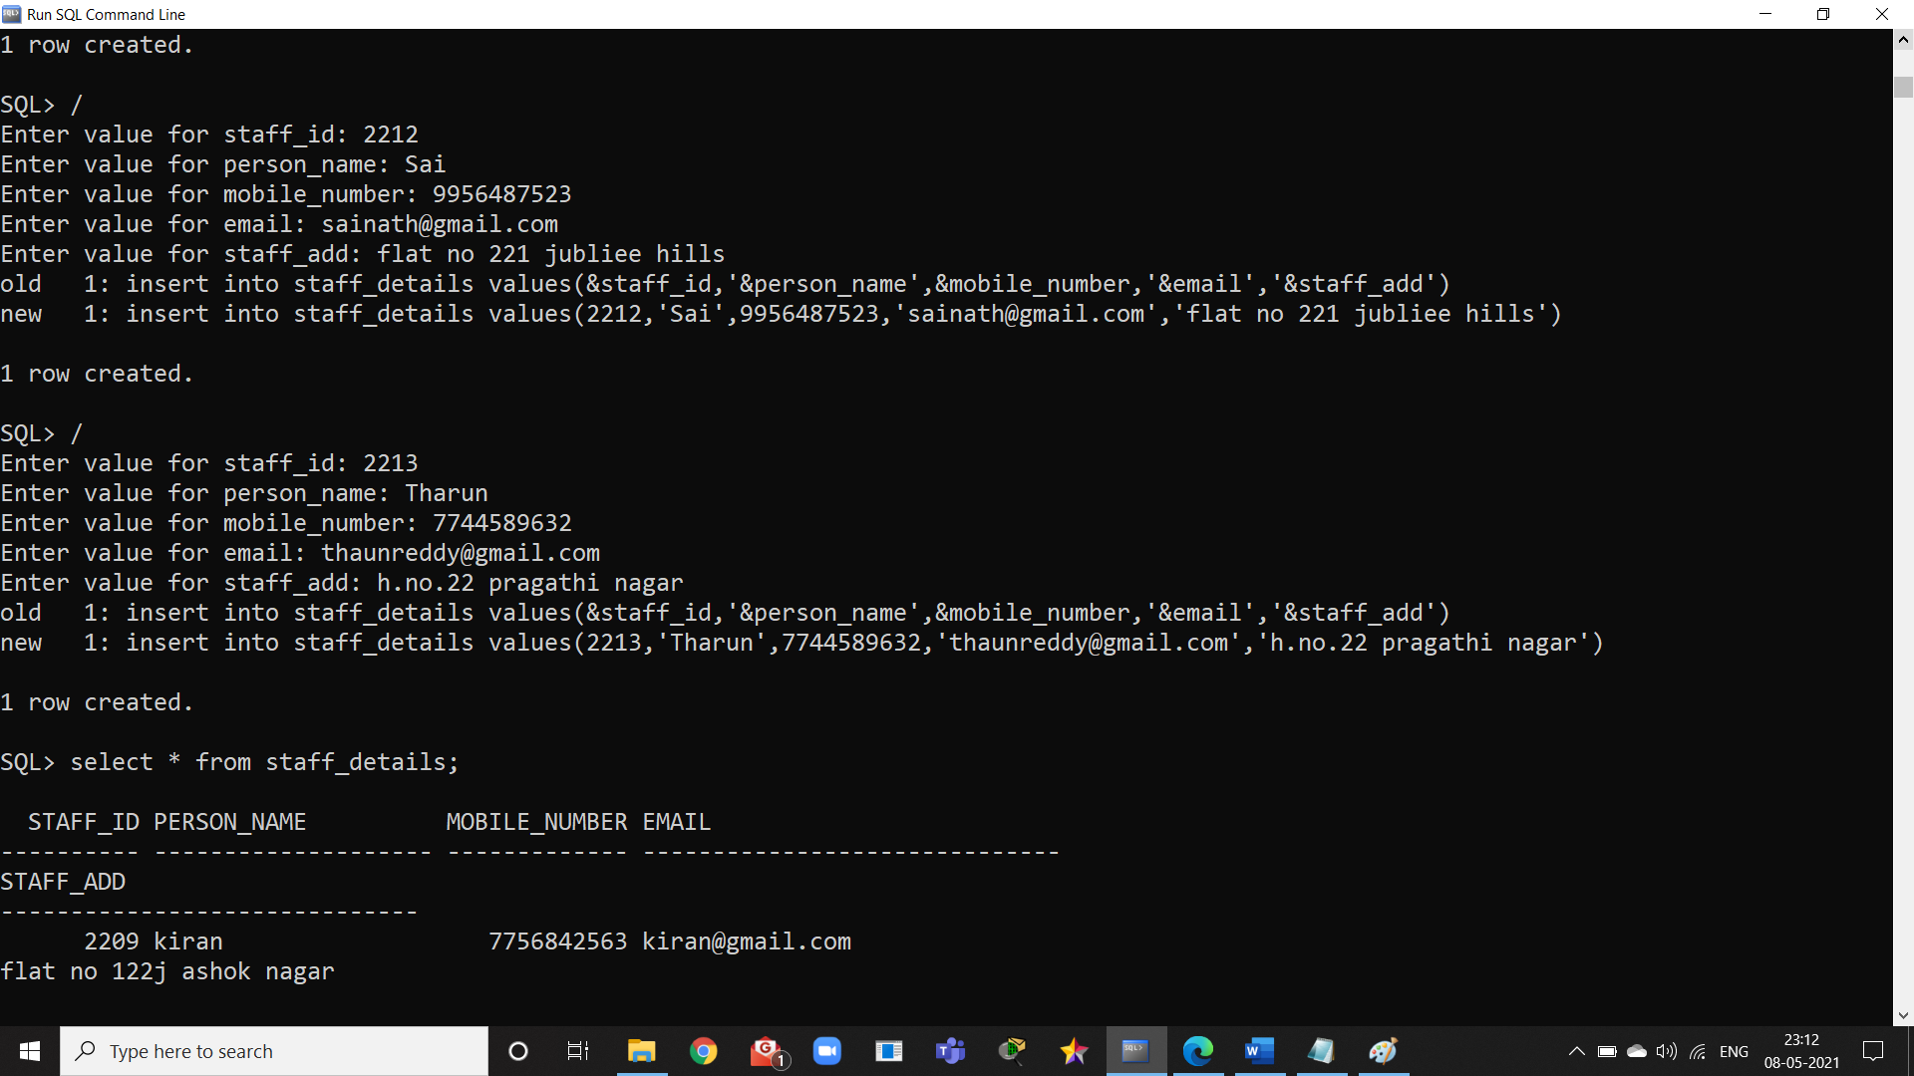

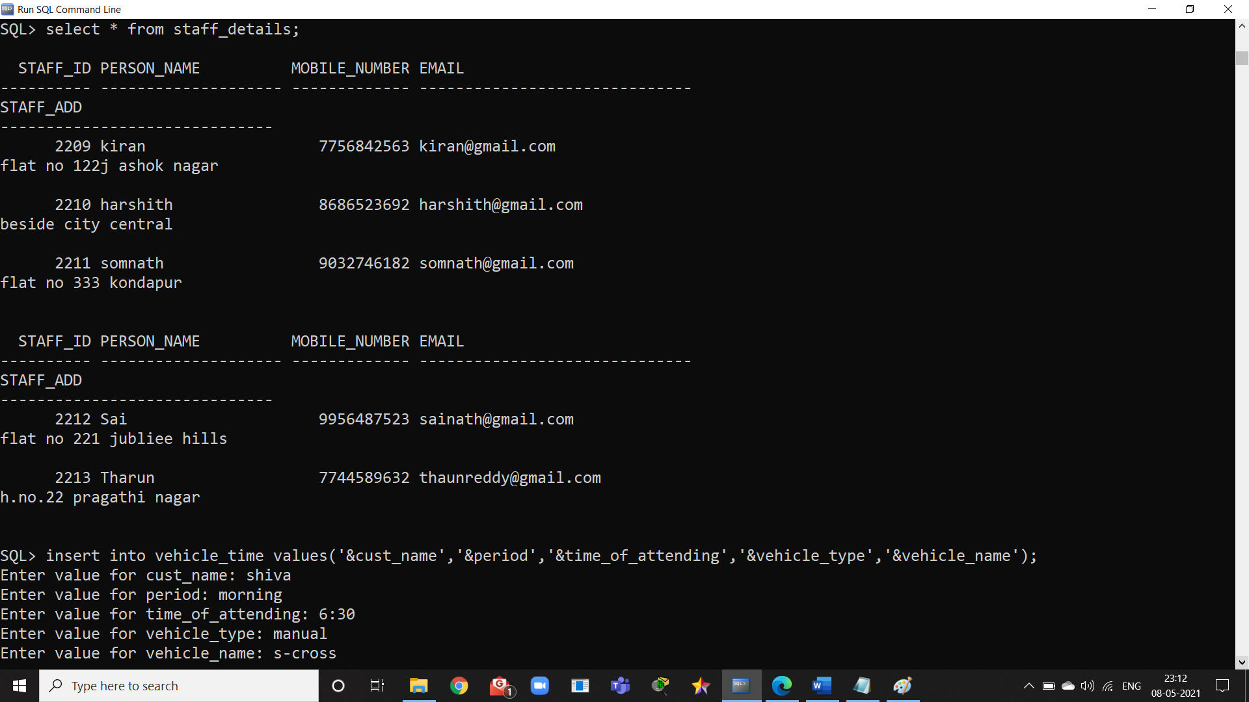

**14**

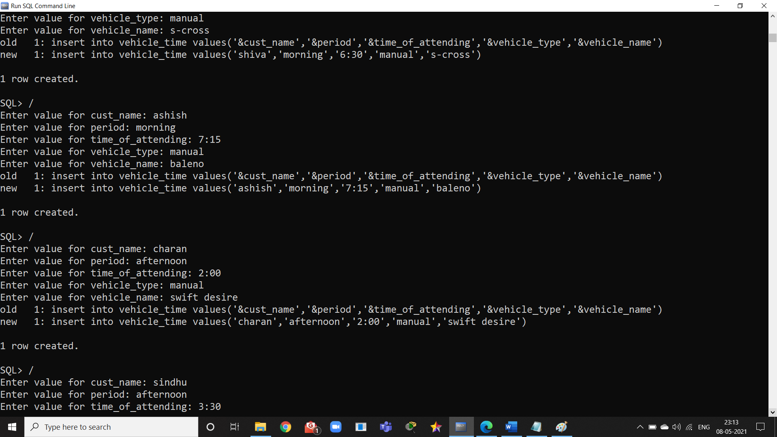

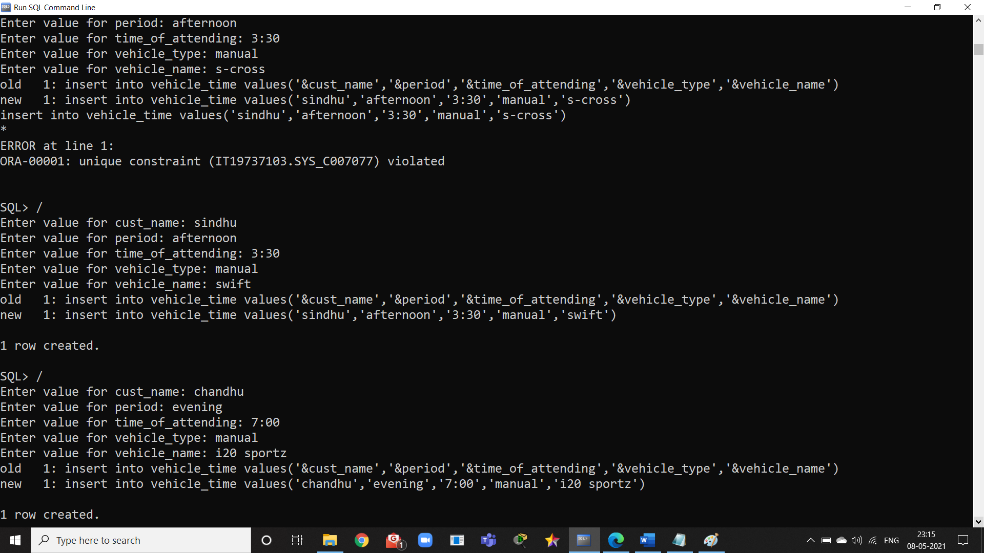

**15**

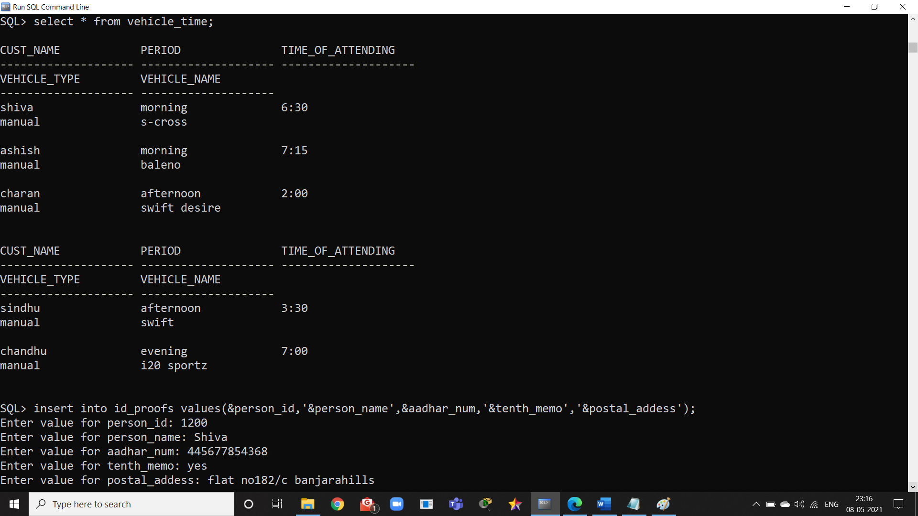

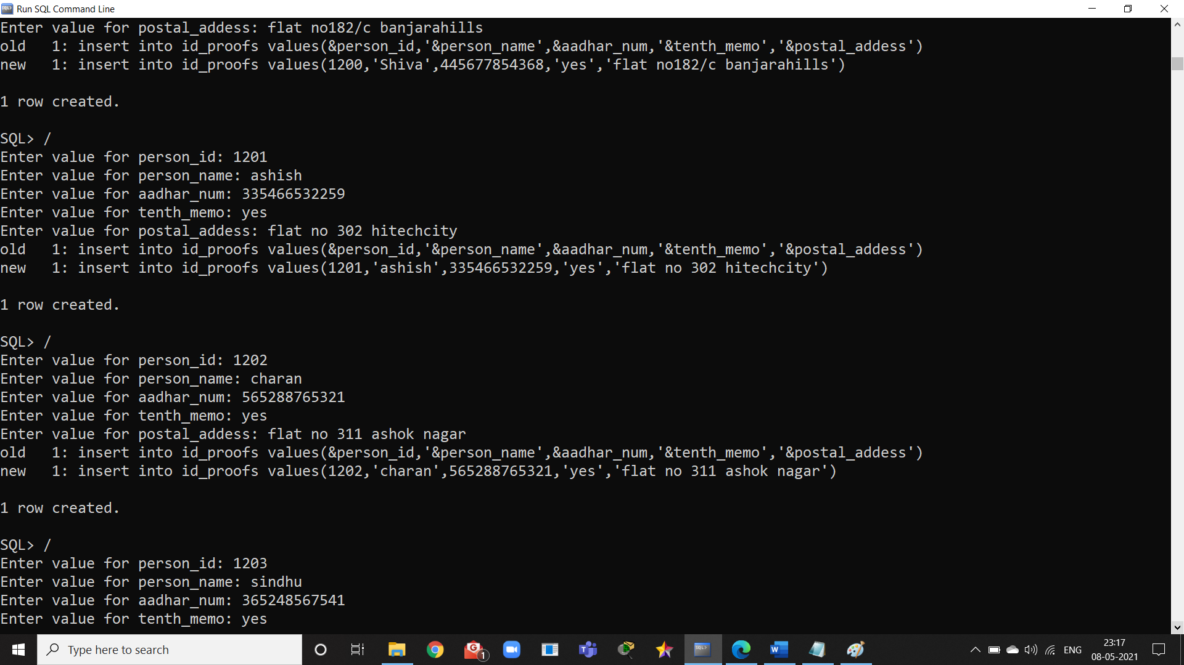

**16**

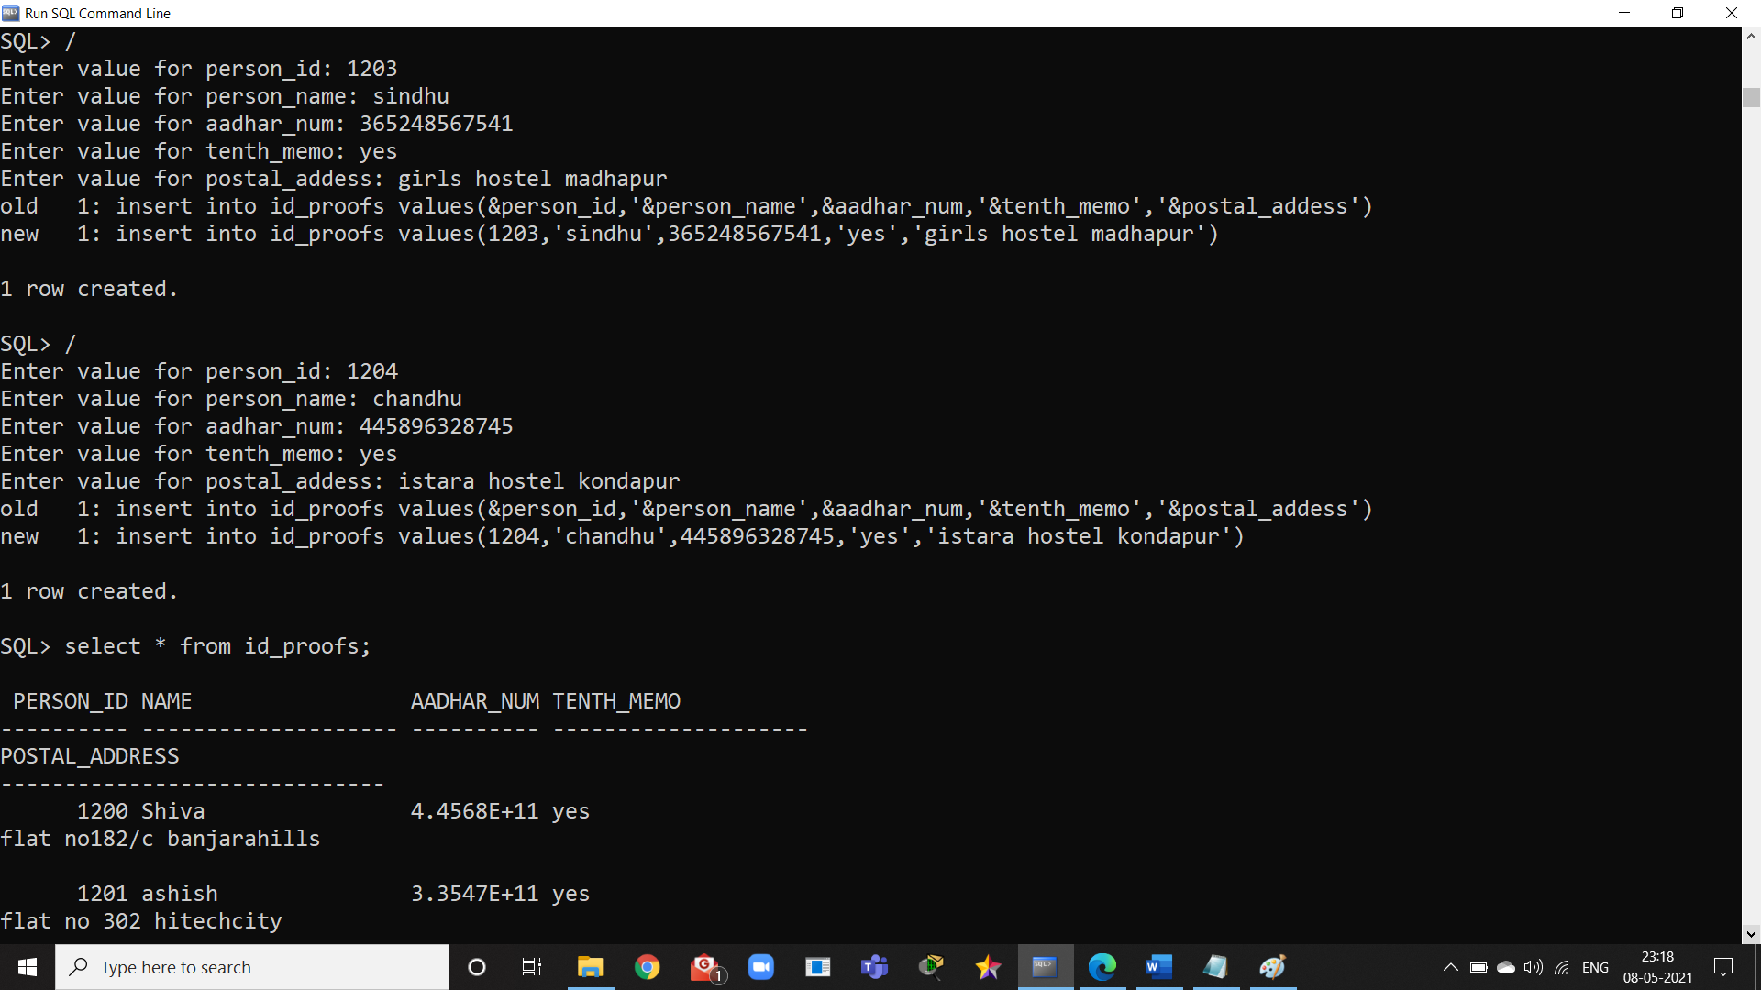

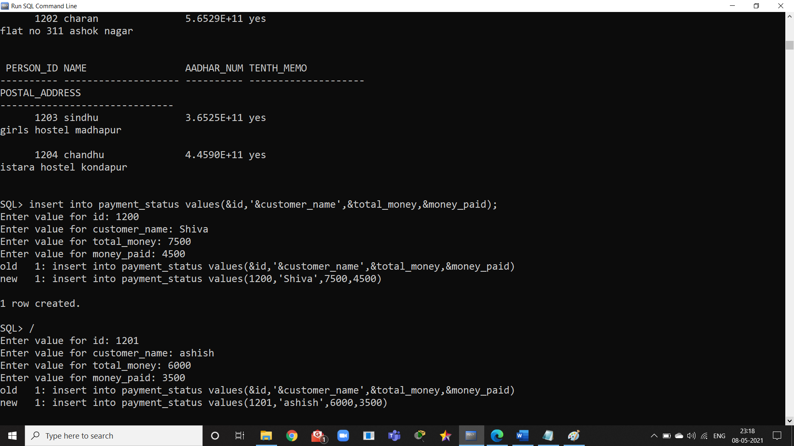

**17**

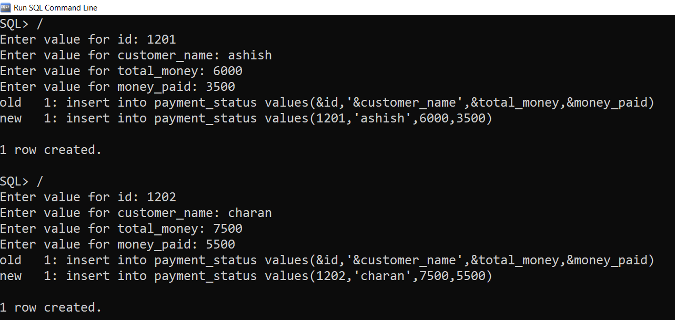

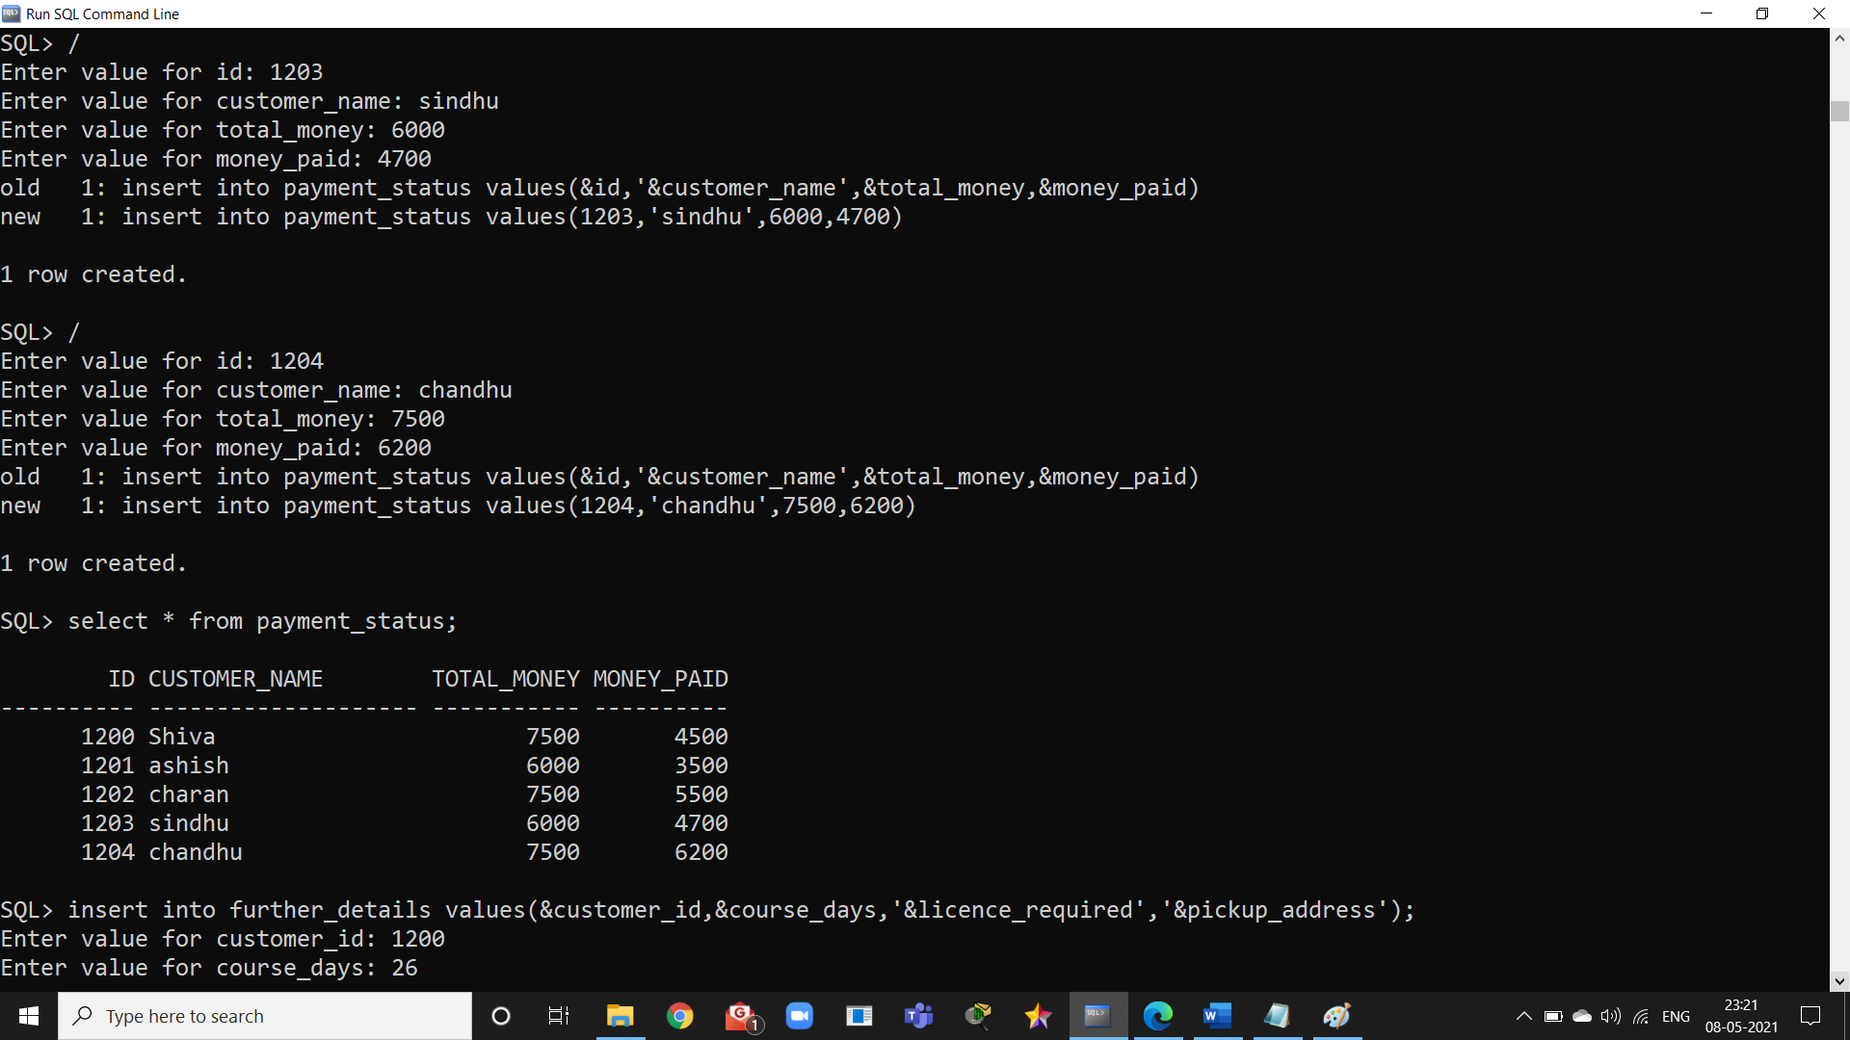

**18**

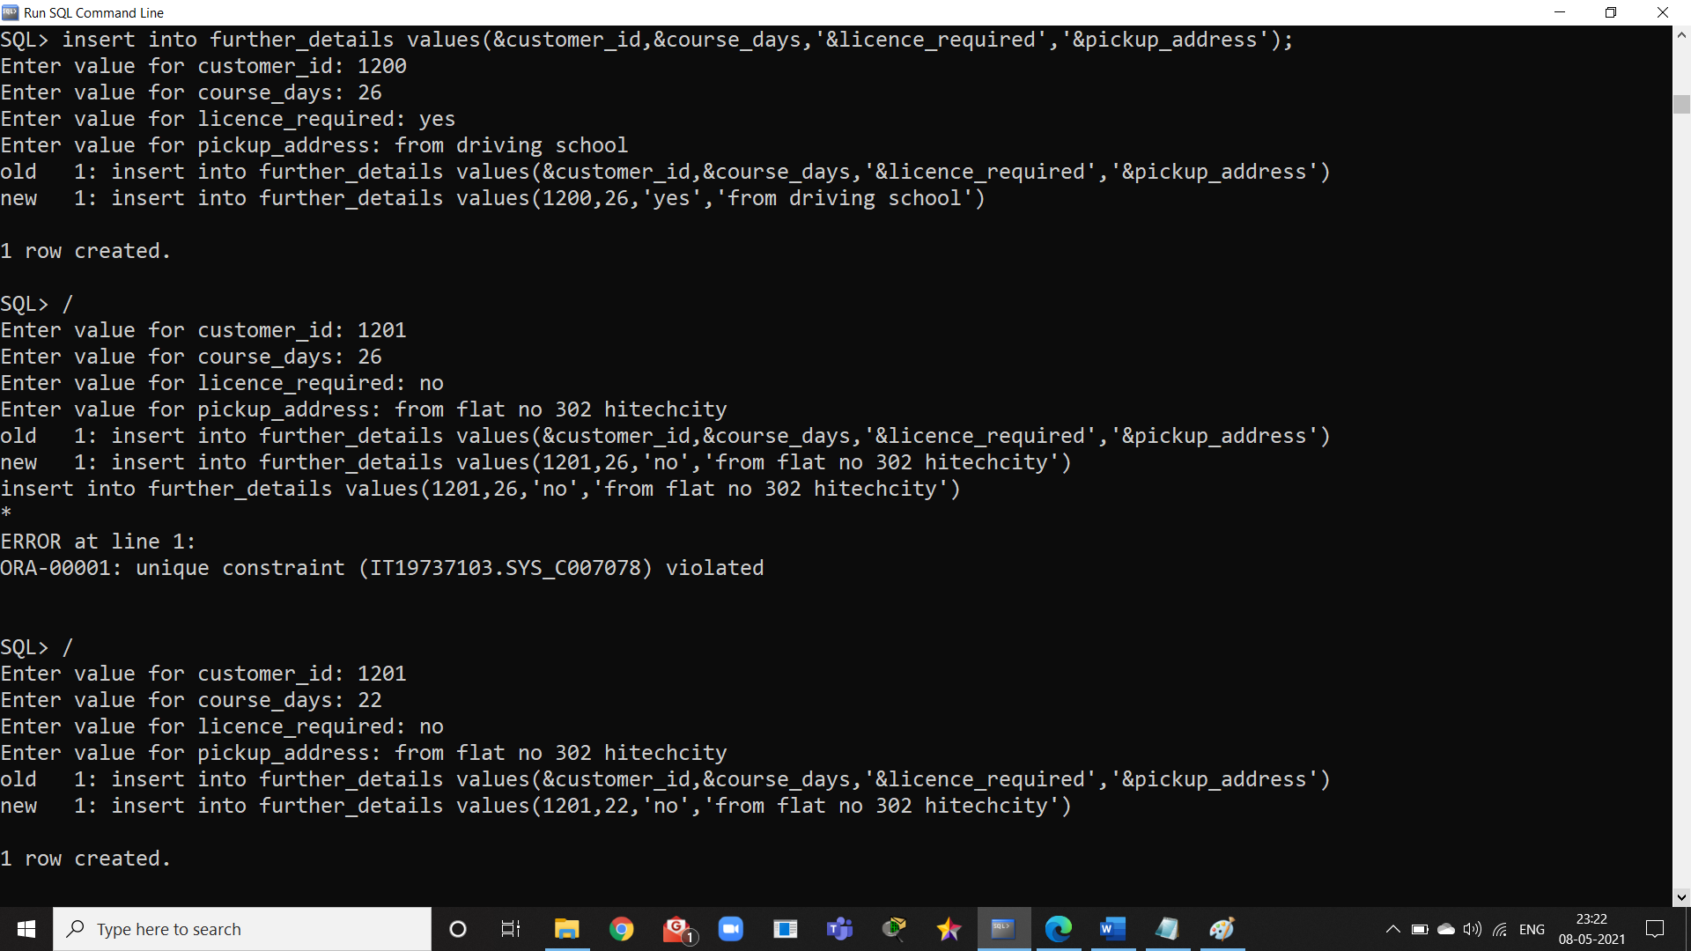

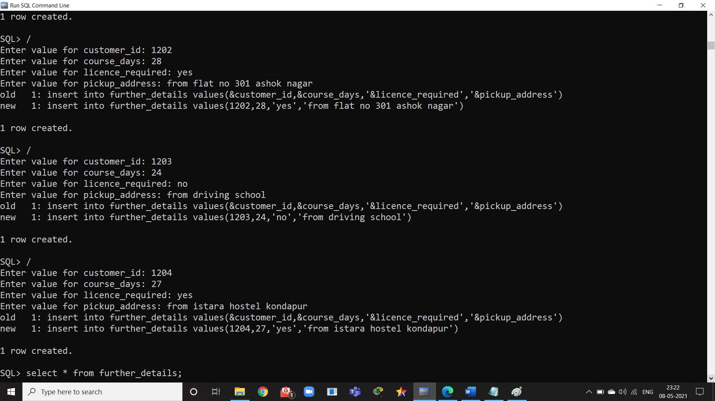

**19**

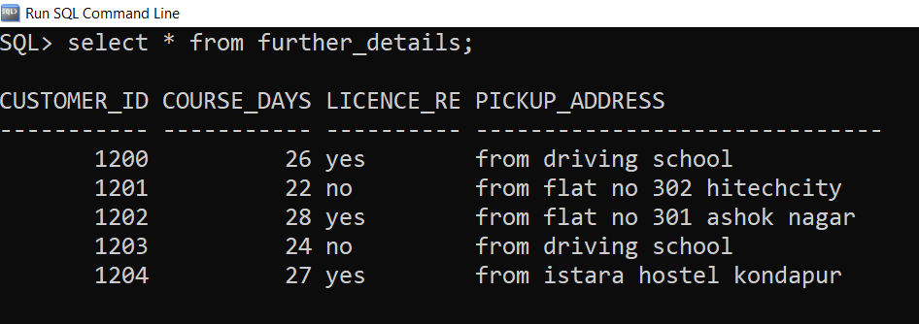

**--------------------------------------------------xxxxxxxxxxxxxxxxxxx----------------------------------------------------**

**20**

**IMPLEMENTATION**

**Front end programs and its connectivity**

Java Database Connectivity (JDBC) is an application programming interface (API) for the programming language Java, which defines how a client may access a database. It is a Java-based data access technology used for Java database connectivity. It is part of the Java Standard Edition platform, from Oracle Corporation. It provides methods to query and update data in a database and is oriented towards relational databases.The connection to the database can be performed using Java programming (JDBC API) as:

**public void** connectToDB()

{

try{

connection=

DriverManager.getConnection("jdbc:oracle:thin:@localhost:1521:xe","it19737103","vasavi");

statement = connection.createStatement();

}

catch (SQLException connectException)

{

System.out.println(connectException.getMessage()); System.out.println(connectException.getSQLState()); System.out.println(connectException.getErrorCode()); System.exit(1);

}

}

Thus, the connection from Java to Oracle database is performed and therefore, can be used for updating tables in the database directly.

**21**

**Driving School Management System Code:**

**MAIN CODE:**

import java.awt.EventQueue;

import java.awt.Image;

import javax.swing.JFrame;

import java.awt.Font;

import javax.swing.JLabel;

import javax.swing.JTabbedPane;

import javax.swing.JPanel;

import javax.swing.ImageIcon;

import java.awt.event.ActionListener;

import java.awt.event.ActionEvent;

import javax.swing.JButton;

import java.awt.Color;

import java.awt.Button;

import javax.swing.SwingConstants;

import java.awt.Panel;

public class customize {

private JFrame frame;

private final JLabel lblNewLabel_5 = new JLabel("New label");

/**

* Launch the application.

*/

public static void main(String[] args) {

EventQueue.invokeLater(new Runnable() {

public void run() {

try {

customize window = new customize();

window.frame.setVisible(true);

} catch (Exception e) {

e.printStackTrace();

}

}

});

}

/**

* Create the application.

*/

public customize() {

initialize();

this.frame.setVisible(true);

}

/**

* Initialize the contents of the frame.

*/

private void initialize() {

frame = new JFrame();

frame.setBounds(100, 100, 662, 490);

frame.setTitle("DRIVING SCHOOL MANAGEMENT SYSTEM");

frame.setDefaultCloseOperation(JFrame.EXIT_ON_CLOSE);

frame.getContentPane().setLayout(null);

JTabbedPane tabbedPane = new JTabbedPane(JTabbedPane.TOP);

tabbedPane.setBounds(10, 39, 641, 416);

frame.getContentPane().add(tabbedPane);

JPanel panel = new JPanel();

tabbedPane.addTab("CUSTOMERS", null, panel, null);

panel.setLayout(null);

JButton btnNewButton = new JButton("ADD CUSTOMER");

btnNewButton.setIcon(new ImageIcon("C:\\Users\\lukka\\Pictures\\Saved Pictures\\add-icon1.png"));

btnNewButton.setFont(new Font("Tahoma", Font.BOLD, 13));

btnNewButton.addActionListener(new ActionListener() {

public void actionPerformed(ActionEvent e) {

if (e.getSource() == btnNewButton) {

ADDCUSTOMER addcust=new ADDCUSTOMER();

}

}

});

btnNewButton.setBounds(21, 69, 195, 39);

panel.add(btnNewButton);

JButton btnNewButton_1 = new JButton("EDIT CUSTOMER");

btnNewButton_1.setIcon(new ImageIcon("C:\\Users\\lukka\\Pictures\\Saved Pictures\\edit-icon.png"));

btnNewButton_1.setFont(new Font("Tahoma", Font.BOLD, 13));

btnNewButton_1.addActionListener(new ActionListener() {

public void actionPerformed(ActionEvent e) {

if (e.getSource() == btnNewButton_1) {

EDITCUSTOMER editcust=new EDITCUSTOMER();

}

}

});

btnNewButton_1.setBounds(21, 155, 195, 39);

panel.add(btnNewButton_1);

JButton btnNewButton_2 = new JButton("DELETE CUSTOMER");

btnNewButton_2.setIcon(new ImageIcon("C:\\Users\\lukka\\Pictures\\Saved Pictures\\delete-file-icon (1).png"));

btnNewButton_2.addActionListener(new ActionListener() {

public void actionPerformed(ActionEvent e) {

if (e.getSource() == btnNewButton_2) {

DELETECUSTOMER delcust=new DELETECUSTOMER();

}

}

});

btnNewButton_2.setFont(new Font("Tahoma", Font.BOLD, 13));

btnNewButton_2.setBounds(21, 238, 195, 39);

panel.add(btnNewButton_2);

JButton btnNewButton_3 = new JButton("VIEW CUSTOMERS");

btnNewButton_3.setIcon(new ImageIcon("C:\\Users\\lukka\\Pictures\\Saved Pictures\\eye-icon (1).png"));

btnNewButton_3.addActionListener(new ActionListener() {

public void actionPerformed(ActionEvent e) {

if (e.getSource() == btnNewButton_3) {

VEIWCUSTOMERS veiwcust=new VEIWCUSTOMERS();

}

}

});

btnNewButton_3.setFont(new Font("Tahoma", Font.BOLD, 13));

btnNewButton_3.setBounds(21, 321, 195, 39);

panel.add(btnNewButton_3);

JLabel lblNewLabel = new JLabel("");

lblNewLabel.setBounds(225, 10, 400, 369);

Image img = new ImageIcon(this.getClass().getResource("/login.png")).getImage();

lblNewLabel.setIcon(new ImageIcon(img));

lblNewLabel.setBounds(225,10,400,396);

panel.add(lblNewLabel);

JPanel panel_1 = new JPanel();

tabbedPane.addTab("VEHICLE TIME", null, panel_1, null);

panel_1.setLayout(null);

JButton btnNewButton_4 = new JButton("ADD VEHICLE_TIME");

btnNewButton_4.setIcon(new ImageIcon("C:\\Users\\lukka\\Pictures\\Saved Pictures\\add-icon1.png"));

btnNewButton_4.setFont(new Font("Tahoma", Font.BOLD, 14));

btnNewButton_4.addActionListener(new ActionListener() {

public void actionPerformed(ActionEvent e) {

ADDVEHICLE addvech = new ADDVEHICLE();

}

});

btnNewButton_4.setBounds(22, 62, 237, 41);

panel_1.add(btnNewButton_4);

JButton btnNewButton_5 = new JButton("EDIT VEHICLE_TIME");

btnNewButton_5.addActionListener(new ActionListener() {

public void actionPerformed(ActionEvent e) {

EDITVEHICLE editvech = new EDITVEHICLE();

}

});

btnNewButton_5.setIcon(new ImageIcon("C:\\Users\\lukka\\Pictures\\Saved Pictures\\edit-icon.png"));

btnNewButton_5.setFont(new Font("Tahoma", Font.BOLD, 14));

btnNewButton_5.setBounds(22, 144, 237, 41);

panel_1.add(btnNewButton_5);

JButton btnNewButton_6 = new JButton("DELETE VEHICLE_TIME");

btnNewButton_6.addActionListener(new ActionListener() {

public void actionPerformed(ActionEvent e) {

DELETEVEHICLE delvech = new DELETEVEHICLE();

}

});

btnNewButton_6.setIcon(new ImageIcon("C:\\Users\\lukka\\Pictures\\Saved Pictures\\delete-file-icon (1).png"));

btnNewButton_6.setFont(new Font("Tahoma", Font.BOLD, 14));

btnNewButton_6.setBounds(22, 228, 248, 41);

panel_1.add(btnNewButton_6);

JButton btnNewButton_7 = new JButton("VIEW VECHILE_TIME");

btnNewButton_7.addActionListener(new ActionListener() {

public void actionPerformed(ActionEvent e) {

VIEWVEHICLE viewvech = new VIEWVEHICLE();

}

});

btnNewButton_7.setFont(new Font("Tahoma", Font.BOLD, 14));

btnNewButton_7.setIcon(new ImageIcon("C:\\Users\\lukka\\Pictures\\Saved Pictures\\eye-icon (1).png"));

btnNewButton_7.setBounds(22, 313, 237, 41);

panel_1.add(btnNewButton_7);

JLabel lblNewLabel_1 = new JLabel("");

lblNewLabel_1.setBounds(433, 62, 187, 296);

Image img1 = new ImageIcon(this.getClass().getResource("/time-icon1.png")).getImage();

lblNewLabel_1.setIcon(new ImageIcon(img1));

lblNewLabel_1.setBounds(300,62,320,296);

panel_1.add(lblNewLabel_1);

Panel panel_2 = new Panel();

tabbedPane.addTab("FURTHER DETAILS", null, panel_2, null);

JButton btnNewButton_8 = new JButton("ADD FURTHER_DETAILS");

btnNewButton_8.setBounds(28, 55, 243, 41);

btnNewButton_8.setHorizontalAlignment(SwingConstants.RIGHT);

btnNewButton_8.setVerticalAlignment(SwingConstants.BOTTOM);

btnNewButton_8.setFont(new Font("Tahoma", Font.BOLD, 14));

btnNewButton_8.setIcon(new ImageIcon("C:\\Users\\lukka\\Pictures\\Saved Pictures\\add-icon1.png"));

btnNewButton_8.addActionListener(new ActionListener() {

public void actionPerformed(ActionEvent e) {

ADDDETAILS adddet = new ADDDETAILS();

}

});

panel_2.setLayout(null);

panel_2.add(btnNewButton_8);

JButton btnNewButton_9 = new JButton("EDIT FURTHER_DETAILS");

btnNewButton_9.addActionListener(new ActionListener() {

public void actionPerformed(ActionEvent e) {

EDITDETAILS eddet = new EDITDETAILS();

}

});

btnNewButton_9.setBounds(28, 141, 247, 41);

btnNewButton_9.setFont(new Font("Tahoma", Font.BOLD, 14));

btnNewButton_9.setIcon(new ImageIcon("C:\\Users\\lukka\\Pictures\\Saved Pictures\\edit-icon.png"));

panel_2.add(btnNewButton_9);

JButton btnNewButton_10 = new JButton("DELETE FURTHER_DETAILS");

btnNewButton_10.setBounds(21, 224, 267, 41);

btnNewButton_10.setIcon(new ImageIcon("C:\\Users\\lukka\\Pictures\\Saved Pictures\\delete-file-icon (1).png"));

btnNewButton_10.addActionListener(new ActionListener() {

public void actionPerformed(ActionEvent e) {

DELETEDETAILS deldet = new DELETEDETAILS();

}

});

btnNewButton_10.setFont(new Font("Tahoma", Font.BOLD, 14));

panel_2.add(btnNewButton_10);

JButton btnNewButton_11 = new JButton("VIEW FURTHER_DETAILS");

btnNewButton_11.addActionListener(new ActionListener() {

public void actionPerformed(ActionEvent e) {

VIEWDETAILS viewdet = new VIEWDETAILS();

}

});

btnNewButton_11.setBounds(22, 306, 253, 41);

btnNewButton_11.setIcon(new ImageIcon("C:\\Users\\lukka\\Pictures\\Saved Pictures\\eye-icon (1).png"));

btnNewButton_11.setFont(new Font("Tahoma", Font.BOLD, 14));

panel_2.add(btnNewButton_11);

JLabel lblNewLabel_2 = new JLabel("");

lblNewLabel_2.setBounds(315, 55, 300, 299);

Image img2 = new ImageIcon(this.getClass().getResource("/Details-icon1.png")).getImage();

lblNewLabel_2.setIcon(new ImageIcon(img2));

lblNewLabel_2.setBounds(315,55,300,299);

panel_2.add(lblNewLabel_2);

Panel panel_3 = new Panel();

tabbedPane.addTab("STAFF DETAILS", null, panel_3, null);

panel_3.setLayout(null);

JButton btnNewButton_12 = new JButton("ADD STAFF_DETAILS");

btnNewButton_12.addActionListener(new ActionListener() {

public void actionPerformed(ActionEvent e) {

ADDSTAFFDETAILS addstaff = new ADDSTAFFDETAILS();

}

});

btnNewButton_12.setIcon(new ImageIcon("C:\\Users\\lukka\\Pictures\\Saved Pictures\\add-icon1.png"));

btnNewButton_12.setFont(new Font("Tahoma", Font.BOLD, 14));

btnNewButton_12.setBounds(25, 44, 226, 42);

panel_3.add(btnNewButton_12);

JButton btnNewButton_13 = new JButton("EDIT STAFF_DETAILS");

btnNewButton_13.addActionListener(new ActionListener() {

public void actionPerformed(ActionEvent e) {

EDITSTAFFDETAILS edstaff = new EDITSTAFFDETAILS();

}

});

btnNewButton_13.setIcon(new ImageIcon("C:\\Users\\lukka\\Pictures\\Saved Pictures\\edit-icon.png"));

btnNewButton_13.setFont(new Font("Tahoma", Font.BOLD, 14));

btnNewButton_13.setBounds(25, 123, 226, 42);

panel_3.add(btnNewButton_13);

JButton btnNewButton_14 = new JButton("DELETE STAFF_DETAILS");

btnNewButton_14.addActionListener(new ActionListener() {

public void actionPerformed(ActionEvent e) {

DELSTAFFDETAILS delstaff = new DELSTAFFDETAILS();

}

});

btnNewButton_14.setIcon(new ImageIcon("C:\\Users\\lukka\\Pictures\\Saved Pictures\\delete-file-icon (1).png"));

btnNewButton_14.setFont(new Font("Tahoma", Font.BOLD, 14));

btnNewButton_14.setBounds(25, 209, 241, 42);

panel_3.add(btnNewButton_14);

JButton btnNewButton_15 = new JButton("VIEW STAFF_DETAILS");

btnNewButton_15.addActionListener(new ActionListener() {

public void actionPerformed(ActionEvent e) {

VIEWSTAFFDETAILS veiwstaff = new VIEWSTAFFDETAILS();

}

});

btnNewButton_15.setIcon(new ImageIcon("C:\\Users\\lukka\\Pictures\\Saved Pictures\\eye-icon (1).png"));

btnNewButton_15.setFont(new Font("Tahoma", Font.BOLD, 14));

btnNewButton_15.setBounds(25, 298, 241, 42);

panel_3.add(btnNewButton_15);

JLabel lblNewLabel_3 = new JLabel("");

lblNewLabel_3.setBounds(304, 47, 322, 319);

Image img3 = new ImageIcon(this.getClass().getResource("/Details-Icon2.png")).getImage();

lblNewLabel_3.setIcon(new ImageIcon(img3));

lblNewLabel_3.setBounds(310,50,325,320);

panel_3.add(lblNewLabel_3);

Panel panel_4 = new Panel();

tabbedPane.addTab("ID_PROOFS&POSTAL", null, panel_4, null);

panel_4.setLayout(null);

JButton btnNewButton_16 = new JButton("ADDPROOFSPOSTAL");

btnNewButton_16.addActionListener(new ActionListener() {

public void actionPerformed(ActionEvent e) {

ADDPROOFSPOSTAL addpos = new ADDPROOFSPOSTAL();

}

});

btnNewButton_16.setIcon(new ImageIcon("C:\\Users\\lukka\\Pictures\\Saved Pictures\\add-icon1.png"));

btnNewButton_16.setFont(new Font("Tahoma", Font.BOLD, 14));

btnNewButton_16.setBounds(30, 43, 239, 43);

panel_4.add(btnNewButton_16);

JButton btnNewButton_17 = new JButton("EDITPROOFSPOSTAL");

btnNewButton_17.addActionListener(new ActionListener() {

public void actionPerformed(ActionEvent e) {

EDITPROOFSPOSTAL edtpost = new EDITPROOFSPOSTAL();

}

});

btnNewButton_17.setIcon(new ImageIcon("C:\\Users\\lukka\\Pictures\\Saved Pictures\\edit-icon.png"));

btnNewButton_17.setFont(new Font("Tahoma", Font.BOLD, 14));

btnNewButton_17.setBounds(30, 124, 239, 43);

panel_4.add(btnNewButton_17);

JButton btnNewButton_18 = new JButton("DELETEPROOFSPOSTAL");

btnNewButton_18.addActionListener(new ActionListener() {

public void actionPerformed(ActionEvent e) {

DELPROOFSPOSTAL delpost = new DELPROOFSPOSTAL();

}

});

btnNewButton_18.setIcon(new ImageIcon("C:\\Users\\lukka\\Pictures\\Saved Pictures\\delete-file-icon (1).png"));

btnNewButton_18.setFont(new Font("Tahoma", Font.BOLD, 14));

btnNewButton_18.setBounds(30, 214, 239, 43);

panel_4.add(btnNewButton_18);

JButton btnNewButton_19 = new JButton("VIEWPROOFSPOSTAL");

btnNewButton_19.setIcon(new ImageIcon("C:\\Users\\lukka\\Pictures\\Saved Pictures\\eye-icon (1).png"));

btnNewButton_19.addActionListener(new ActionListener() {

public void actionPerformed(ActionEvent e) {

VIEWPROOFSPOSTAL viepos = new VIEWPROOFSPOSTAL();

}

});

btnNewButton_19.setFont(new Font("Tahoma", Font.BOLD, 14));

btnNewButton_19.setBounds(30, 305, 239, 43);

panel_4.add(btnNewButton_19);

JLabel lblNewLabel_4 = new JLabel("");

lblNewLabel_4.setBounds(319, 38, 284, 310);

Image img4 = new ImageIcon(this.getClass().getResource("/contact-icon.png")).getImage();

lblNewLabel_4.setIcon(new ImageIcon(img4));

lblNewLabel_4.setBounds(320,50,300,320);

panel_4.add(lblNewLabel_4);

Panel panel_5 = new Panel();

tabbedPane.addTab("PAYMENT_STATUS", null, panel_5, null);

panel_5.setLayout(null);

JButton btnNewButton_20 = new JButton("ADDPAYMENT");

btnNewButton_20.setIcon(new ImageIcon("C:\\Users\\lukka\\Pictures\\Saved Pictures\\add-icon1.png"));

btnNewButton_20.setFont(new Font("Tahoma", Font.BOLD, 14));

btnNewButton_20.addActionListener(new ActionListener() {

public void actionPerformed(ActionEvent e) {

ADDPAYMENT addpay = new ADDPAYMENT();

}

});

btnNewButton_20.setBounds(27, 30, 197, 37);

panel_5.add(btnNewButton_20);

JButton btnNewButton_21 = new JButton("EDIT PAYMENT");

btnNewButton_21.setIcon(new ImageIcon("C:\\Users\\lukka\\Pictures\\Saved Pictures\\edit-icon.png"));

btnNewButton_21.setFont(new Font("Tahoma", Font.BOLD, 14));

btnNewButton_21.addActionListener(new ActionListener() {

public void actionPerformed(ActionEvent e) {

EDITPAYMENT edpay = new EDITPAYMENT();

}

});

btnNewButton_21.setBounds(27, 113, 197, 37);

panel_5.add(btnNewButton_21);

JButton btnNewButton_22 = new JButton("DELETE PAYMENT");

btnNewButton_22.addActionListener(new ActionListener() {

public void actionPerformed(ActionEvent e) {

DELETEPAYMENT delpay = new DELETEPAYMENT();

}

});

btnNewButton_22.setIcon(new ImageIcon("C:\\Users\\lukka\\Pictures\\Saved Pictures\\delete-file-icon (1).png"));

btnNewButton_22.setFont(new Font("Tahoma", Font.BOLD, 14));

btnNewButton_22.setBounds(27, 194, 197, 37);

panel_5.add(btnNewButton_22);

JButton btnNewButton_23 = new JButton("VIEW PAYMENT");

btnNewButton_23.addActionListener(new ActionListener() {

public void actionPerformed(ActionEvent e) {

VIEWPAYMENT vpay = new VIEWPAYMENT();

}

});

btnNewButton_23.setIcon(new ImageIcon("C:\\Users\\lukka\\Pictures\\Saved Pictures\\eye-icon (1).png"));

btnNewButton_23.setFont(new Font("Tahoma", Font.BOLD, 14));

btnNewButton_23.setBounds(27, 274, 197, 37);

panel_5.add(btnNewButton_23);

JLabel lblNewLabel_6 = new JLabel("");

lblNewLabel_6.setBounds(270, 44, 322, 312);

Image img5 = new ImageIcon(this.getClass().getResource("/rep-icon.png")).getImage();

lblNewLabel_6.setIcon(new ImageIcon(img5));

lblNewLabel_6.setBounds(320,50,300,320);

panel_5.add(lblNewLabel_6);

}

}

**ADD DETAILS:**

//import java.awt.EventQueue;

import javax.swing.JFrame;

import javax.swing.JOptionPane;

import javax.swing.JLabel;

import java.awt.Font;

import java.awt.Image;

import javax.swing.JTextField;

import javax.swing.ImageIcon;

import javax.swing.JButton;

import java.awt.event.ActionListener;

import java.sql.Connection;

import java.sql.DriverManager;

import java.sql.ResultSet;

import java.sql.SQLException;

import java.sql.Statement;

import java.sql.PreparedStatement;

import java.awt.event.ActionEvent;

import javax.swing.SwingConstants;

public class ADDDETAILS {

private JFrame frame;

private JTextField textField;

private JTextField textField_1;

private JTextField textField_2;

Connection con;

Statement stmt;

ResultSet rs;

private JTextField textField_3;

//private JTextField textField_4;

/**

* Create the application.

*/

public ADDDETAILS() {

try

{

Class.forName("oracle.jdbc.driver.OracleDriver");

}

catch (Exception e)

{

System.err.println("Unable to find and load driver");

System.exit(1);

}

connectToDB();

initialize();

this.frame.setVisible(true);

}

void connectToDB()

{

try

{

con = DriverManager.getConnection("jdbc:oracle:thin:@localhost:1521:xe","it19737103","vasavi");

stmt = con.createStatement();

}

catch (SQLException connectException)

{

System.out.println(connectException.getMessage());

System.out.println(connectException.getSQLState());

System.out.println(connectException.getErrorCode());

System.exit(1);

}

}

/**

* Initialize the contents of the frame.

*/

private void initialize() {

frame = new JFrame();

frame.setBounds(100, 100, 926, 506);

frame.setTitle("DRIVING SCHOOL MANAGEMENT SYSTEM");

frame.setDefaultCloseOperation(JFrame.EXIT_ON_CLOSE);

frame.getContentPane().setLayout(null);

JLabel lblNewLabel = new JLabel("CUSTOMER_ID:");

lblNewLabel.setFont(new Font("Tahoma", Font.BOLD, 16));

lblNewLabel.setBounds(87, 50, 132, 29);

frame.getContentPane().add(lblNewLabel);

JLabel lblNewLabel_1 = new JLabel("COURSE_DAYS:");

lblNewLabel_1.setFont(new Font("Tahoma", Font.BOLD, 16));

lblNewLabel_1.setBounds(87, 89, 181, 32);

frame.getContentPane().add(lblNewLabel_1);

JLabel lblNewLabel_2 = new JLabel("LICENCE_REQUIRED:");

lblNewLabel_2.setFont(new Font("Tahoma", Font.BOLD, 16));

lblNewLabel_2.setBounds(87, 131, 181, 39);

frame.getContentPane().add(lblNewLabel_2);

textField = new JTextField();

textField.setBounds(299, 43, 189, 28);

frame.getContentPane().add(textField);

textField.setColumns(10);

textField_1 = new JTextField();

textField_1.setBounds(299, 94, 189, 28);

frame.getContentPane().add(textField_1);

textField_1.setColumns(10);

textField_2 = new JTextField();

textField_2.setBounds(299, 137, 190, 31);

frame.getContentPane().add(textField_2);

textField_2.setColumns(10);

/*btnNewButton_1.setFont(new Font("Tahoma", Font.BOLD, 16));

btnNewButton_1.setBounds(488, 395, 120, 39);

frame.getContentPane().add(btnNewButton_1);

*/

JLabel lblNewLabel_3 = new JLabel("PICKUP_ADDRESS:");

lblNewLabel_3.setFont(new Font("Tahoma", Font.BOLD, 16));

lblNewLabel_3.setBounds(87, 180, 162, 32);

frame.getContentPane().add(lblNewLabel_3);

textField_3 = new JTextField();

textField_3.setBounds(299, 178, 189, 28);

frame.getContentPane().add(textField_3);

textField_3.setColumns(10);

/*JLabel lblNewLabel_4 = new JLabel("VEHICLE_NAME:");

lblNewLabel_4.setFont(new Font("Tahoma", Font.BOLD, 16));

lblNewLabel_4.setBounds(87, 229, 162, 28);

frame.getContentPane().add(lblNewLabel_4);

textField_4 = new JTextField();

textField_4.setBounds(299, 231, 189, 29);

frame.getContentPane().add(textField_4);

textField_4.setColumns(10);

JLabel lblNewLabel_5 = new JLabel("EMAIL_ID:");

lblNewLabel_5.setFont(new Font("Tahoma", Font.BOLD, 16));

lblNewLabel_5.setBounds(103, 279, 132, 28);

frame.getContentPane().add(lblNewLabel_5);

textField_5 = new JTextField();

textField_5.setBounds(299, 283, 189, 26);

frame.getContentPane().add(textField_5);

textField_5.setColumns(10);

JLabel lblNewLabel_6 = new JLabel("ADDRESS:");

lblNewLabel_6.setFont(new Font("Tahoma", Font.BOLD, 16));

lblNewLabel_6.setBounds(103, 331, 120, 26);

frame.getContentPane().add(lblNewLabel_6);

textField_6 = new JTextField();

textField_6.setBounds(299, 324, 189, 32);

frame.getContentPane().add(textField_6);

textField_6.setColumns(10);*/

frame.setDefaultCloseOperation(JFrame.EXIT_ON_CLOSE);

JButton btnNewButton = new JButton("SUBMIT");

btnNewButton.addActionListener(new ActionListener() {

public void actionPerformed(ActionEvent e) {

if (e.getSource() == btnNewButton) {

int customer_id;

int course_days;

String licence_required;

customer_id = Integer.parseInt(textField.getText());

course_days = Integer.parseInt(textField_1.getText());

licence_required = textField_2.getText();

String pickup_address = textField_3.getText();

// String vehicle_name = textField_4.getText();

//String email_id = textField_5.getText();

//String address = textField_6.getText();

try {

PreparedStatement pstmt = con.prepareStatement("insert into further_details(customer_id,course_days,licence_required,pickup_address) values (?,?,?,?)");

pstmt.setInt(1, customer_id);

pstmt.setInt(2, course_days);

pstmt.setString(3, licence_required);

pstmt.setString(4, pickup_address);

// pstmt.setString(5, vehicle_name);

// pstmt.setString(6, email_id);

//pstmt.setString(7, address);

int i=pstmt.executeUpdate();

JOptionPane.showMessageDialog(null, "\nInserted " + i + " rows successfully");

}

catch(Exception E)

{

JOptionPane.showMessageDialog(null, "\nCheck the details!!!");

System.out.println(E);}

}

}

});

btnNewButton.setFont(new Font("Tahoma", Font.BOLD, 16));

btnNewButton.setBounds(206, 395, 189, 39);

frame.getContentPane().add(btnNewButton);

JButton btnNewButton_2 = new JButton("CLEAR");

btnNewButton_2.setFont(new Font("Tahoma", Font.BOLD, 16));

btnNewButton_2.setBounds(463, 397, 126, 39);

frame.getContentPane().add(btnNewButton_2);

JLabel lblNewLabel_7 = new JLabel("ADD DETAILS:");

lblNewLabel_7.setVerticalAlignment(SwingConstants.TOP);

lblNewLabel_7.setFont(new Font("Tahoma", Font.BOLD, 22));

lblNewLabel_7.setBounds(513, 128, 389, 250);

Image img = new ImageIcon(this.getClass().getResource("/add-cust.png")).getImage();

lblNewLabel_7.setIcon(new ImageIcon(img));

lblNewLabel_7.setBounds(513, 146, 400,271);

frame.getContentPane().add(lblNewLabel_7);

/*JLabel lblNewLabel_8 = new JLabel("");

lblNewLabel_8.setBounds(564, 101, 311, 267);

Image img = new ImageIcon(this.getClass().getResource("/add-cust.png")).getImage();

lblNewLabel.setIcon(new ImageIcon(img));

lblNewLabel.setBounds(564, 101, 311, 267);

frame.getContentPane().add(lblNewLabel_8);

*/

//JButton btnNewButton_2 = new JButton("clear");

btnNewButton_2.addActionListener(new ActionListener() {

public void actionPerformed(ActionEvent e) {

if (e.getSource() == btnNewButton_2) {

textField.setText("");

textField_1.setText("");

textField_2.setText("");

textField_3.setText("");

// textField_4.setText("");

//textField_5.setText("");

// textField_6.setText("");

}

}

});

}

}

**EDIT DETAILS:**

//import java.awt.EventQueue;

import javax.swing.JFrame;

import javax.swing.JOptionPane;

import javax.swing.JLabel;

import java.awt.Font;

import java.awt.Image;

import javax.swing.JTextField;

import javax.swing.ImageIcon;

import javax.swing.JButton;

import java.awt.event.ActionListener;

import java.sql.Connection;

import java.sql.DriverManager;

import java.sql.ResultSet;

import java.sql.SQLException;

import java.sql.Statement;

import java.sql.PreparedStatement;

import java.awt.event.ActionEvent;

import javax.swing.SwingConstants;

public class EDITDETAILS {

private JFrame frame;

private JTextField textField;

private JTextField textField_1;

private JTextField textField_2;

Connection con;

Statement stmt;

ResultSet rs;

private JTextField textField_3;

//private JTextField textField_4;

/**

* Create the application.

*/

public EDITDETAILS() {

try

{

Class.forName("oracle.jdbc.driver.OracleDriver");

}

catch (Exception e)

{

System.err.println("Unable to find and load driver");

System.exit(1);

}

connectToDB();

initialize();

this.frame.setVisible(true);

}

void connectToDB()

{

try

{

con = DriverManager.getConnection("jdbc:oracle:thin:@localhost:1521:xe","it19737103","vasavi");

stmt = con.createStatement();

}

catch (SQLException connectException)

{

System.out.println(connectException.getMessage());

System.out.println(connectException.getSQLState());

System.out.println(connectException.getErrorCode());

System.exit(1);

}

}

/**

* Initialize the contents of the frame.

*/

private void initialize() {

frame = new JFrame();

frame.setBounds(100, 100, 926, 506);

frame.setTitle("DRIVING SCHOOL MANAGEMENT SYSTEM");

frame.setDefaultCloseOperation(JFrame.EXIT_ON_CLOSE);

frame.getContentPane().setLayout(null);

JLabel lblNewLabel = new JLabel("CUSTOMER_ID:");

lblNewLabel.setFont(new Font("Tahoma", Font.BOLD, 16));

lblNewLabel.setBounds(87, 50, 132, 29);

frame.getContentPane().add(lblNewLabel);

JLabel lblNewLabel_1 = new JLabel("COURSE_DAYS:");

lblNewLabel_1.setFont(new Font("Tahoma", Font.BOLD, 16));

lblNewLabel_1.setBounds(87, 89, 181, 32);

frame.getContentPane().add(lblNewLabel_1);

JLabel lblNewLabel_2 = new JLabel("LICENCE_REQUIRED:");

lblNewLabel_2.setFont(new Font("Tahoma", Font.BOLD, 16));

lblNewLabel_2.setBounds(87, 131, 181, 39);

frame.getContentPane().add(lblNewLabel_2);

textField = new JTextField();

textField.setBounds(299, 43, 189, 28);

frame.getContentPane().add(textField);

textField.setColumns(10);

textField_1 = new JTextField();

textField_1.setBounds(299, 94, 189, 28);

frame.getContentPane().add(textField_1);

textField_1.setColumns(10);

textField_2 = new JTextField();

textField_2.setBounds(299, 137, 190, 31);

frame.getContentPane().add(textField_2);

textField_2.setColumns(10);

/*btnNewButton_1.setFont(new Font("Tahoma", Font.BOLD, 16));

btnNewButton_1.setBounds(488, 395, 120, 39);

frame.getContentPane().add(btnNewButton_1);

*/

JLabel lblNewLabel_3 = new JLabel("PICKUP_ADDRESS:");

lblNewLabel_3.setFont(new Font("Tahoma", Font.BOLD, 16));

lblNewLabel_3.setBounds(87, 180, 162, 32);

frame.getContentPane().add(lblNewLabel_3);

textField_3 = new JTextField();

textField_3.setBounds(299, 178, 189, 28);

frame.getContentPane().add(textField_3);

textField_3.setColumns(20);

/*

JLabel lblNewLabel_4 = new JLabel("VEHICLE_NAME:");

lblNewLabel_4.setFont(new Font("Tahoma", Font.BOLD, 16));

lblNewLabel_4.setBounds(87, 229, 162, 28);

frame.getContentPane().add(lblNewLabel_4);

textField_4 = new JTextField();

textField_4.setBounds(299, 231, 189, 29);

frame.getContentPane().add(textField_4);

textField_4.setColumns(10);

JLabel lblNewLabel_5 = new JLabel("EMAIL_ID:");

lblNewLabel_5.setFont(new Font("Tahoma", Font.BOLD, 16));

lblNewLabel_5.setBounds(103, 279, 132, 28);

frame.getContentPane().add(lblNewLabel_5);

textField_5 = new JTextField();

textField_5.setBounds(299, 283, 189, 26);

frame.getContentPane().add(textField_5);

textField_5.setColumns(10);

JLabel lblNewLabel_6 = new JLabel("ADDRESS:");

lblNewLabel_6.setFont(new Font("Tahoma", Font.BOLD, 16));

lblNewLabel_6.setBounds(103, 331, 120, 26);

frame.getContentPane().add(lblNewLabel_6);

textField_6 = new JTextField();

textField_6.setBounds(299, 324, 189, 32);

frame.getContentPane().add(textField_6);

textField_6.setColumns(10);*/

frame.setDefaultCloseOperation(JFrame.EXIT_ON_CLOSE);

JButton btnNewButton = new JButton("MODIFY!");

btnNewButton.addActionListener(new ActionListener() {

public void actionPerformed(ActionEvent e) {

if (e.getSource() == btnNewButton) {

int customer_id;

int course_days;

String licence_required;

customer_id = Integer.parseInt(textField.getText());

course_days = Integer.parseInt(textField_1.getText());

licence_required = textField_2.getText();

String pickup_address = textField_3.getText();

// String vehicle_name = textField_4.getText();

//String email_id = textField_5.getText();

//String address = textField_6.getText();

try {

PreparedStatement pstmt = con.prepareStatement("update further_details set customer_id=(?),licence_required=(?),pickup_address=(?) where course_days=(?)");

pstmt.setInt(1, customer_id);

pstmt.setString(2, licence_required);

pstmt.setString(3, pickup_address);

pstmt.setInt(4, course_days);

// pstmt.setString(5, vehicle_name);

// pstmt.setString(6, email_id);

//pstmt.setString(7, address);

int i=pstmt.executeUpdate();

JOptionPane.showMessageDialog(null, "\nUpdated " + i + " rows successfully");

}

catch(Exception E)

{

JOptionPane.showMessageDialog(null, "\nCheck the details!!!");

System.out.println(E);}

}

}

});

btnNewButton.setFont(new Font("Tahoma", Font.BOLD, 16));

btnNewButton.setBounds(206, 395, 189, 39);

frame.getContentPane().add(btnNewButton);

JButton btnNewButton_2 = new JButton("GET HELP");

btnNewButton_2.setFont(new Font("Tahoma", Font.ITALIC, 16));

btnNewButton_2.setBounds(463, 397, 126, 39);

frame.getContentPane().add(btnNewButton_2);

JLabel lblNewLabel_7 = new JLabel("EDIT DETAILS");

lblNewLabel_7.setVerticalAlignment(SwingConstants.TOP);

lblNewLabel_7.setFont(new Font("Tahoma", Font.BOLD, 22));

lblNewLabel_7.setBounds(513, 128, 389, 250);

Image img = new ImageIcon(this.getClass().getResource("/Edit-cust.png")).getImage();

lblNewLabel_7.setIcon(new ImageIcon(img));

lblNewLabel_7.setBounds(513, 146, 400,271);

frame.getContentPane().add(lblNewLabel_7);

btnNewButton_2.addActionListener(new ActionListener() {

public void actionPerformed(ActionEvent e) {

if (e.getSource() == btnNewButton_2) {

JOptionPane.showMessageDialog(null, "You can refer existing columns in view FURTHER DETAILS!!!");

}

}

});

}

}

**DELETE DETAILS:**

//import java.awt.EventQueue;

import javax.swing.JFrame;

//import javax.swing.JTextArea;

import java.awt.Font;

import java.awt.Image;

import javax.swing.JLabel;

import javax.swing.JOptionPane;

import javax.swing.JTextField;

import javax.swing.ImageIcon;

import javax.swing.JButton;

//import java.awt.Color;

import java.awt.event.ActionListener;

import java.sql.Connection;

import java.sql.DriverManager;

import java.sql.PreparedStatement;

import java.sql.ResultSet;

import java.sql.SQLException;

import java.sql.Statement;

import java.awt.event.ActionEvent;

public class DELETEDETAILS {

private JFrame frame;

private JTextField textField;

//private JTextField textField_1;

//private JTextField textField_2;

Connection con;

Statement stmt;

ResultSet rs;

//private JTextField textField_3;

/**

* Create the application.

*/

public DELETEDETAILS() {

try

{

Class.forName("oracle.jdbc.driver.OracleDriver");

}

catch (Exception e)

{

System.err.println("Unable to find and load driver");

System.exit(1);

}

connectToDB();

initialize();

this.frame.setVisible(true);

}

void connectToDB()

{

try

{

con = DriverManager.getConnection("jdbc:oracle:thin:@localhost:1521:xe","it19737103","vasavi");

stmt = con.createStatement();

}

catch (SQLException connectException)

{

System.out.println(connectException.getMessage());

System.out.println(connectException.getSQLState());

System.out.println(connectException.getErrorCode());

System.exit(1);

}

}

/**

* Initialize the contents of the frame.

*/

private void initialize() {

frame = new JFrame();

frame.setBounds(100, 100, 854, 505);

frame.setTitle("DRIVING SCHOOL MANAGEMENT SYSTEM");

frame.setDefaultCloseOperation(JFrame.EXIT_ON_CLOSE);

frame.getContentPane().setLayout(null);

JLabel lblNewLabel = new JLabel("COURSE_DAYS:");

lblNewLabel.setFont(new Font("Tahoma", Font.BOLD, 16));

lblNewLabel.setBounds(124, 216, 139, 29);

frame.getContentPane().add(lblNewLabel);

textField = new JTextField();

textField.setBounds(272, 218, 96, 29);

frame.getContentPane().add(textField);

textField.setColumns(20);

JButton btnNewButton = new JButton("DELETE");

btnNewButton.addActionListener(new ActionListener() {

public void actionPerformed(ActionEvent e) {

if (e.getSource() == btnNewButton) {

try {

int course_days;

course_days=Integer.parseInt(textField.getText());

PreparedStatement pstmt = con.prepareStatement("delete from further_details where course_days=(?)");

pstmt.setInt(1, course_days);

int i=pstmt.executeUpdate();

JOptionPane.showMessageDialog(null, "\nDeleted " + i + " rows successfully");

}

catch(Exception E)

{

JOptionPane.showMessageDialog(null, "Wrong Entry!!!");

System.out.println(E);

}

}

}

});

btnNewButton.setFont(new Font("Tahoma", Font.BOLD, 16));

btnNewButton.setBounds(160, 356, 104, 38);

frame.getContentPane().add(btnNewButton);

JButton btnNewButton_1 = new JButton("GET HELP");

btnNewButton_1.addActionListener(new ActionListener() {

public void actionPerformed(ActionEvent e) {

if (e.getSource() == btnNewButton_1) {

JOptionPane.showMessageDialog(null, "You can refer existing columns in view furter_details!!!");

}

}

});

btnNewButton_1.setFont(new Font("Tahoma", Font.BOLD, 15));

btnNewButton_1.setBounds(342, 356, 104, 38);

frame.getContentPane().add(btnNewButton_1);

JLabel lblNewLabel_3 = new JLabel("DELETE VEHICLE RECORD");

lblNewLabel_3.setFont(new Font("Monospaced", Font.BOLD, 27));

lblNewLabel_3.setBounds(168, 37, 399, 47);

frame.getContentPane().add(lblNewLabel_3);

JLabel lblNewLabel_1 = new JLabel("");

lblNewLabel_1.setBounds(458, 99, 356, 295);

Image img = new ImageIcon(this.getClass().getResource("/Delete-icon.png")).getImage();

lblNewLabel_1.setIcon(new ImageIcon(img));

lblNewLabel_1.setBounds(458,99,356,295);

frame.getContentPane().add(lblNewLabel_1);

}

}

**VIEW DETAILS:**

//import java.awt.EventQueue;

//import javax.swing.ImageIcon;

import javax.swing.JFrame;

import javax.swing.JOptionPane;

import javax.swing.JTextPane;

import java.awt.Font;

//import java.awt.Image;

import java.sql.Connection;

import java.sql.DriverManager;

import java.sql.ResultSet;

import java.sql.SQLException;

import java.sql.Statement;

import javax.swing.JTable;

import javax.swing.ListSelectionModel;

import javax.swing.table.DefaultTableModel;

//import javax.swing.JLabel;

public class VIEWDETAILS {

private JFrame frame;

private JTable table;

String[][] tbl=new String[100][100];

Connection con;

Statement stmt;

ResultSet rs;

//private JLabel lblNewLabel;

/**

* Create the application.

*/

VIEWDETAILS() {

try

{

Class.forName("oracle.jdbc.driver.OracleDriver");

}

catch (Exception e)

{

System.err.println("Unable to find and load driver");

System.exit(1);

}

connectToDB();

initialize();

this.frame.setVisible(true);

}

void connectToDB()

{

try

{

con = DriverManager.getConnection("jdbc:oracle:thin:@localhost:1521:xe","it19737103","vasavi");

stmt = con.createStatement();

}

catch (SQLException connectException)

{

System.out.println(connectException.getMessage());

System.out.println(connectException.getSQLState());

System.out.println(connectException.getErrorCode());

System.exit(1);

}

}

/**

* Initialize the contents of the frame.

*/

private void initialize() {

frame = new JFrame();

frame.setTitle("DRIVING SCHOOL MANAGEMENT SYSTEM");

frame.setBounds(100, 100, 797, 503);

frame.setDefaultCloseOperation(JFrame.EXIT_ON_CLOSE);

frame.getContentPane().setLayout(null);

JTextPane txtpnOfficerDetails = new JTextPane();

txtpnOfficerDetails.setFont(new Font("Monospaced", Font.BOLD, 24));

txtpnOfficerDetails.setText("FURTHER DETAILS");

txtpnOfficerDetails.setBounds(140, 23, 269, 32);

frame.getContentPane().add(txtpnOfficerDetails);

try {

ResultSet rs=stmt.executeQuery("select * from further_details");

int i=0;

while(rs.next()) {

tbl[i][0]=rs.getString(1);

tbl[i][1]=rs.getString(2);

tbl[i][2]=rs.getString(3);

tbl[i][3]=rs.getString(4);

/*tbl[i][4]=rs.getString(5);

tbl[i][5]=rs.getString(6);

tbl[i][6]=rs.getString(7);*/

i=i+1;

}

for(i=0;i<10;i++) {

System.out.println(tbl[i][0]+" "+tbl[i][1]+" "+tbl[i][2]+" "+tbl[i][3]+" ");

}

table = new JTable();

table.setRowSelectionAllowed(false);

table.setSurrendersFocusOnKeystroke(true);

table.setModel(new DefaultTableModel(

tbl,

new String[] {

"CUSTOMER_ID", "COURSE_DAYS", "LICENCE_REQUIRED","PICKUP_ADDRESS"

}

));

table.setSelectionMode(ListSelectionModel.SINGLE_SELECTION);

table.setBounds(10, 72, 770, 150);

frame.getContentPane().add(table);

/* lblNewLabel = new JLabel("");

lblNewLabel.setBounds(406, 10, 206, 141);

Image img = new ImageIcon(this.getClass().getResource("/people-2-icon.png")).getImage();

lblNewLabel.setIcon(new ImageIcon(img));

lblNewLabel.setBounds(225,10,400,396);

frame.getContentPane().add(lblNewLabel);

*/}

catch(Exception E)

{

JOptionPane.showMessageDialog(null, "\nIncorrect Approach!");

System.out.println(E);

}

}

}

**GITHUB LINK:** https://github.com/shiva-103/DrivingSchoolManagementSystem

**OUTPUTS SCREENSHOTS:**

Login:

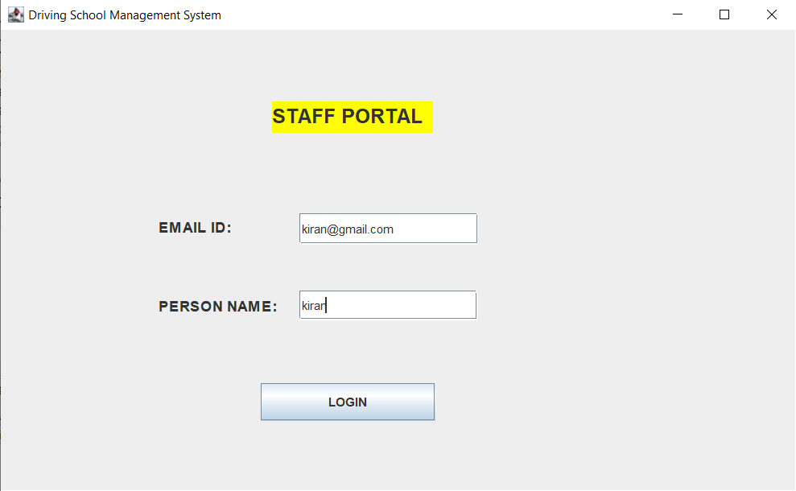After login:

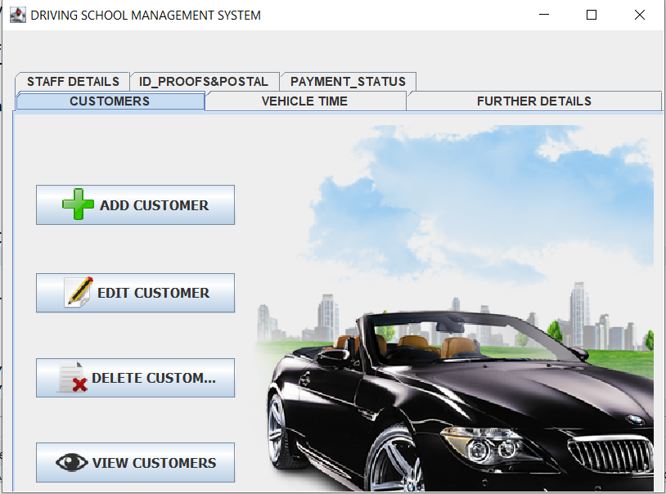

**ADD Customer:**

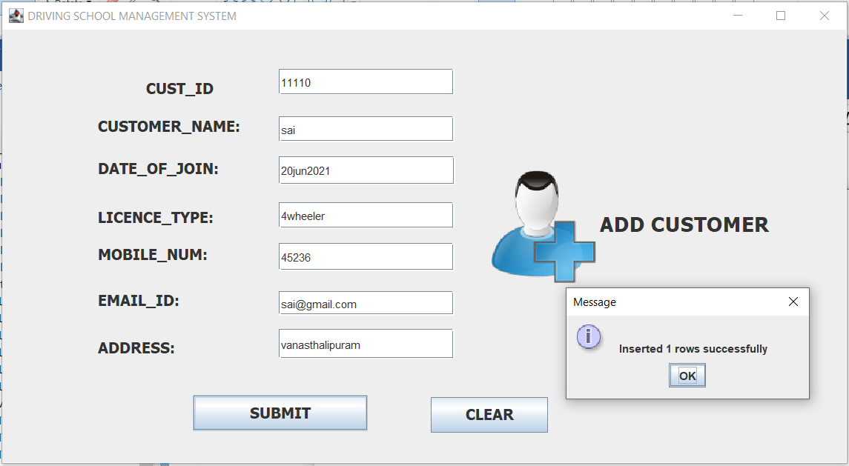

**EDIT CUSTOMER:**

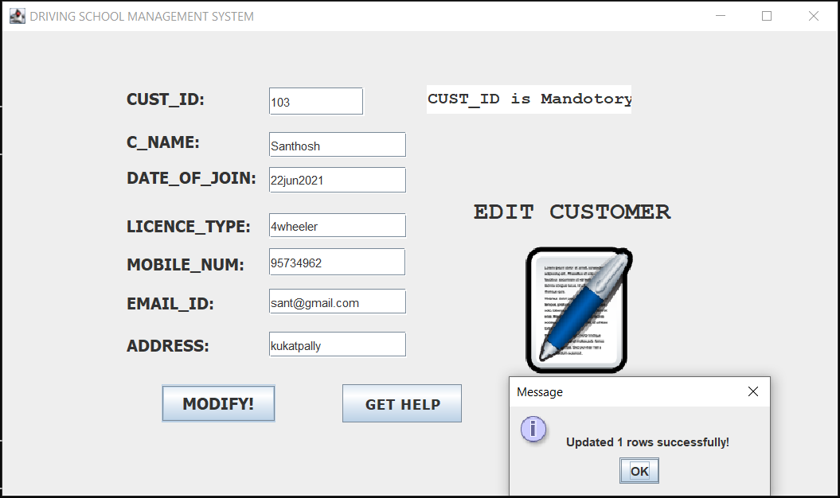

**DELETE CUSTOMER:**

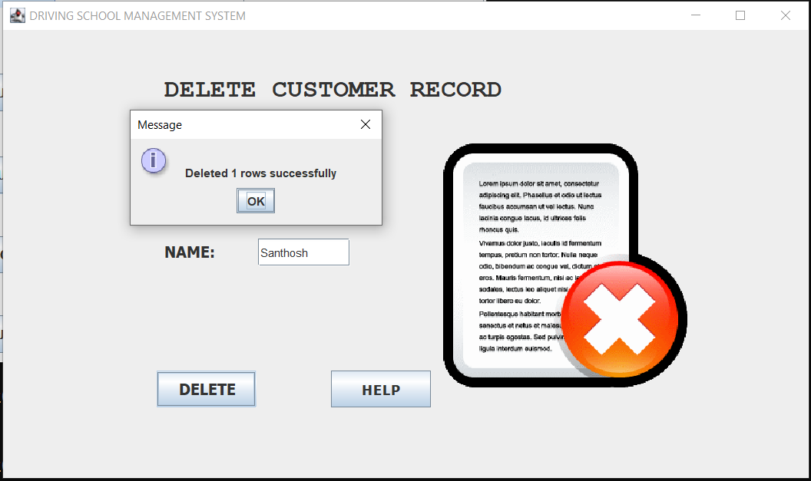

**VIEW CUSTOMERS:**

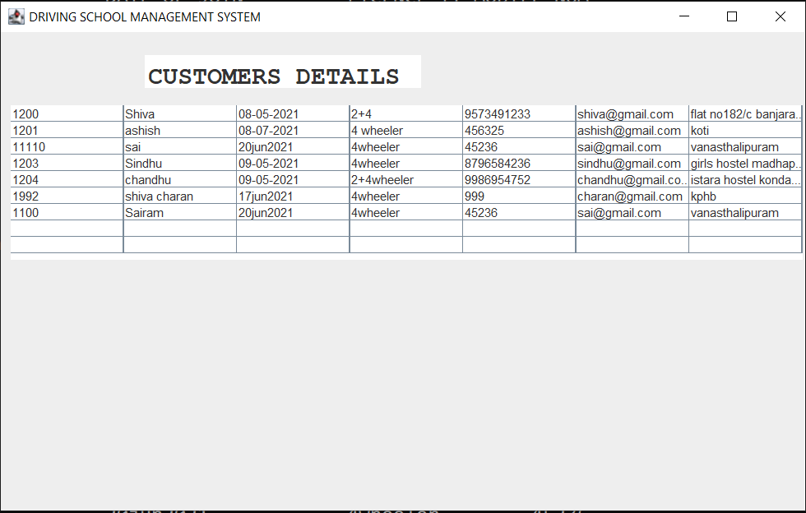

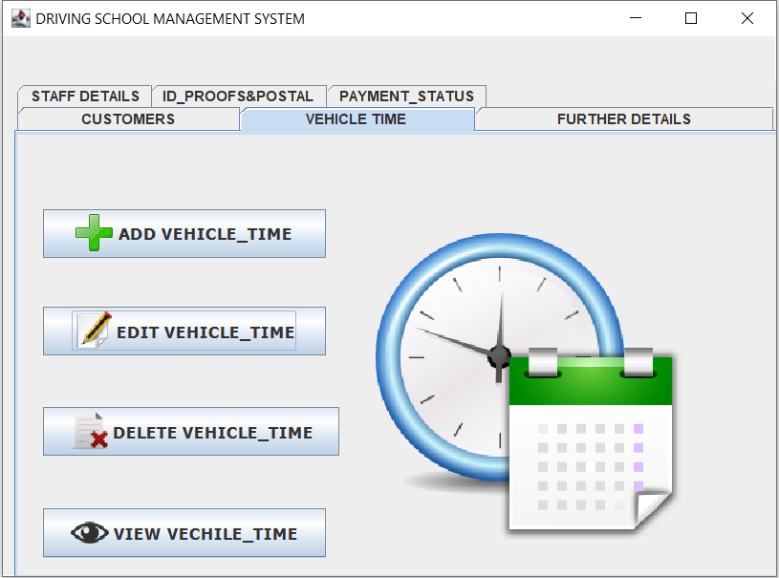

**ADD VEHICLE_TIME:**

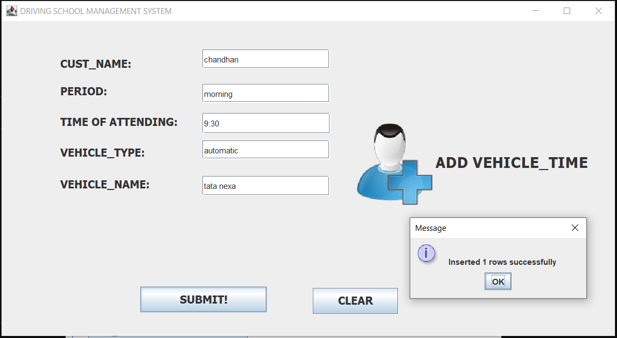

**EDIT VEHICLE_TIME:**

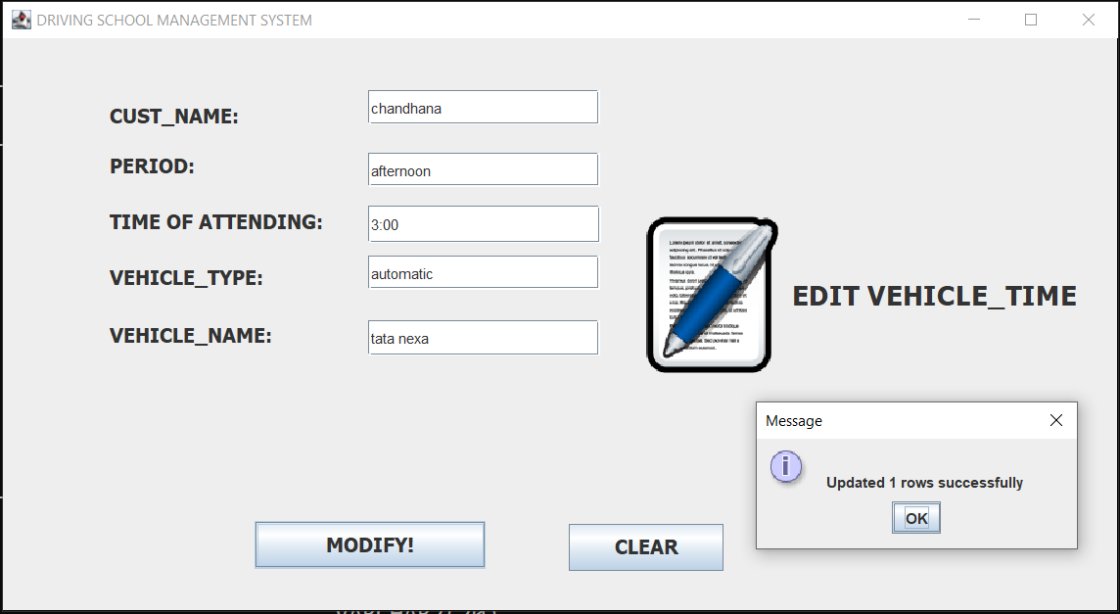

**DELETE VEHICLE_TIME:**

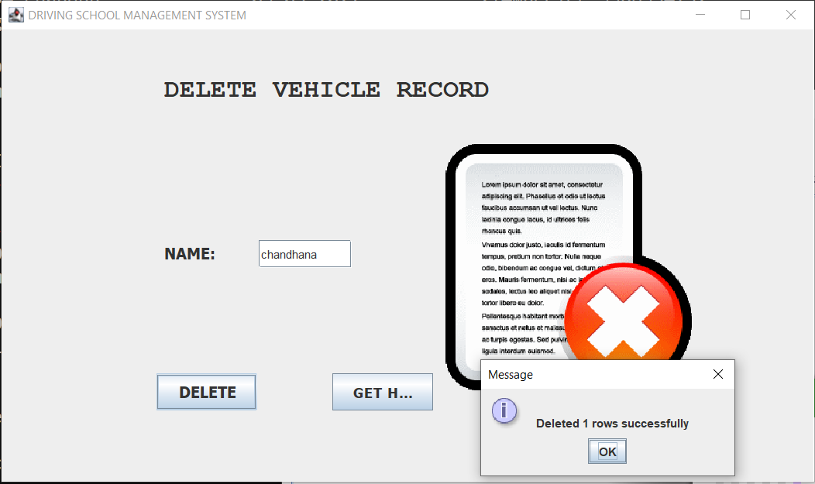

**VIEW VEHICLE_TIME:**

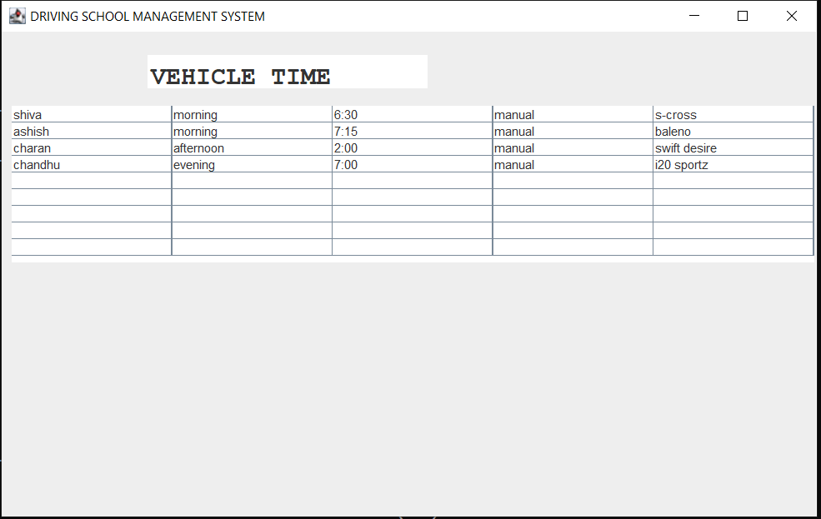

**FURTHER_DETAILS:**

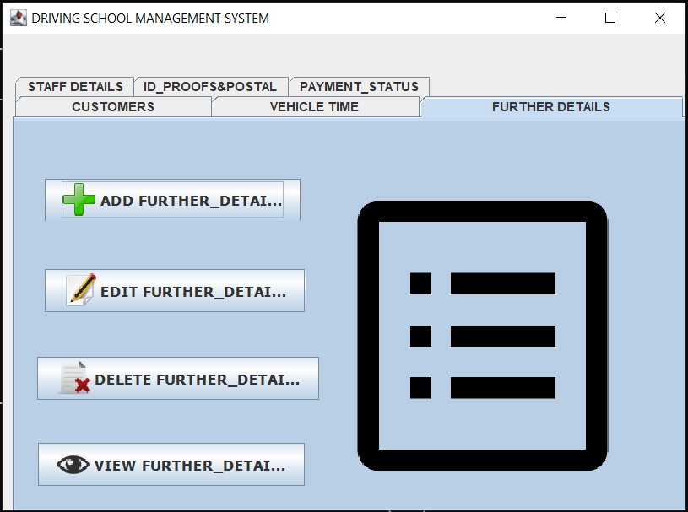

**ADD FURTHER_DETAILS:**

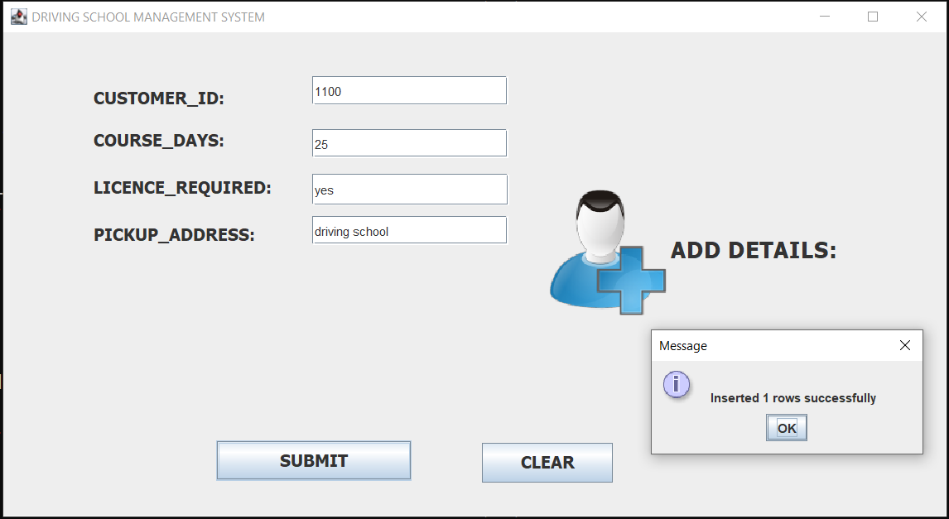

**EDIT FURTHER_DETAILS:**

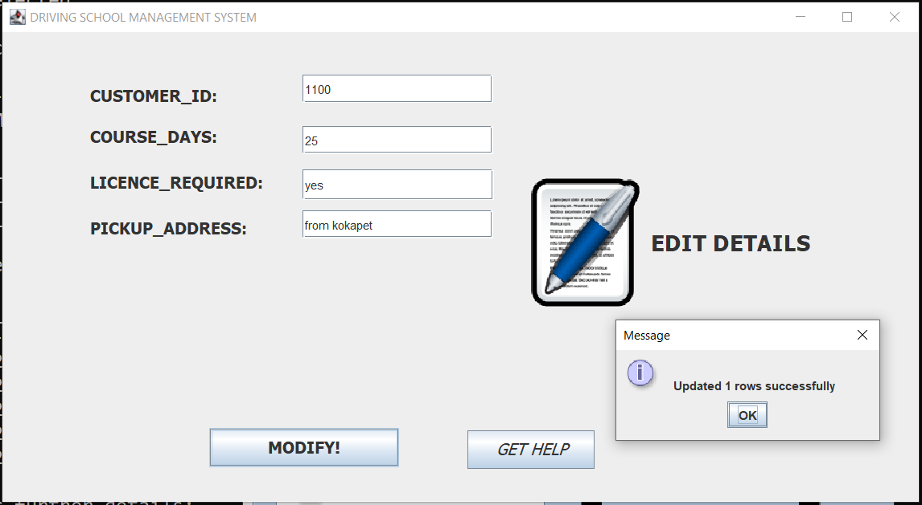

**DELETE FURTHER_DETAILS:**

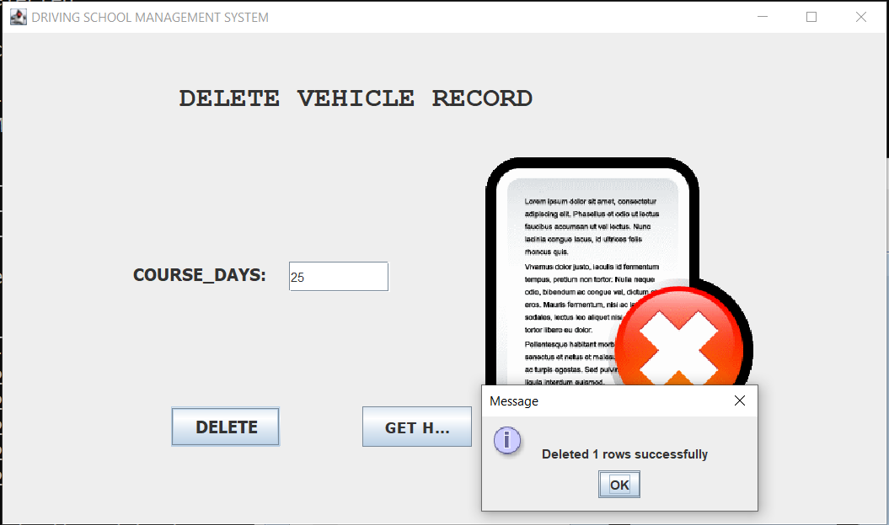

**VIEW FURTHER_DETAILS:**

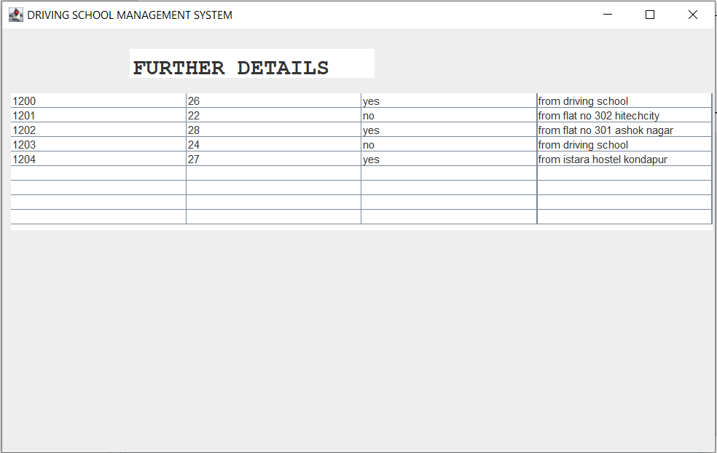

**STAFF_DETAILS:**

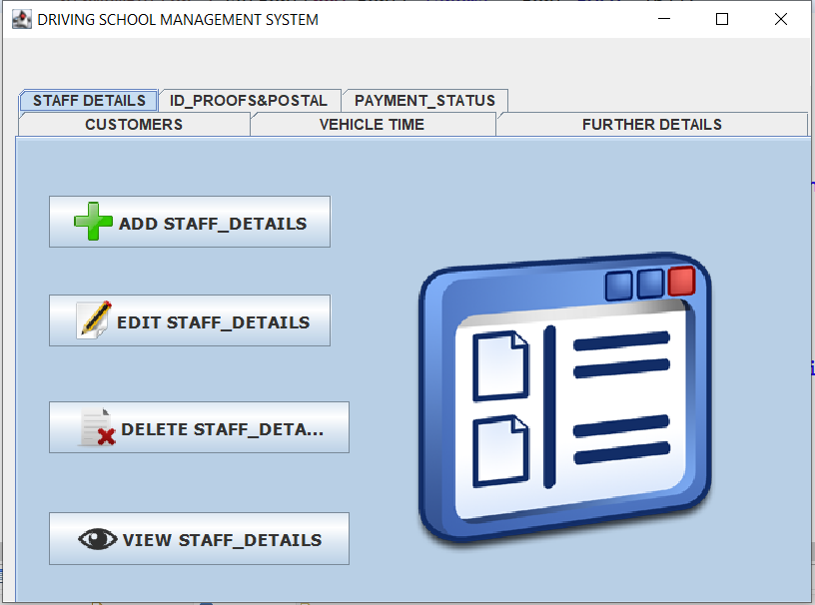

**ADD STAFF_DETAILS:**

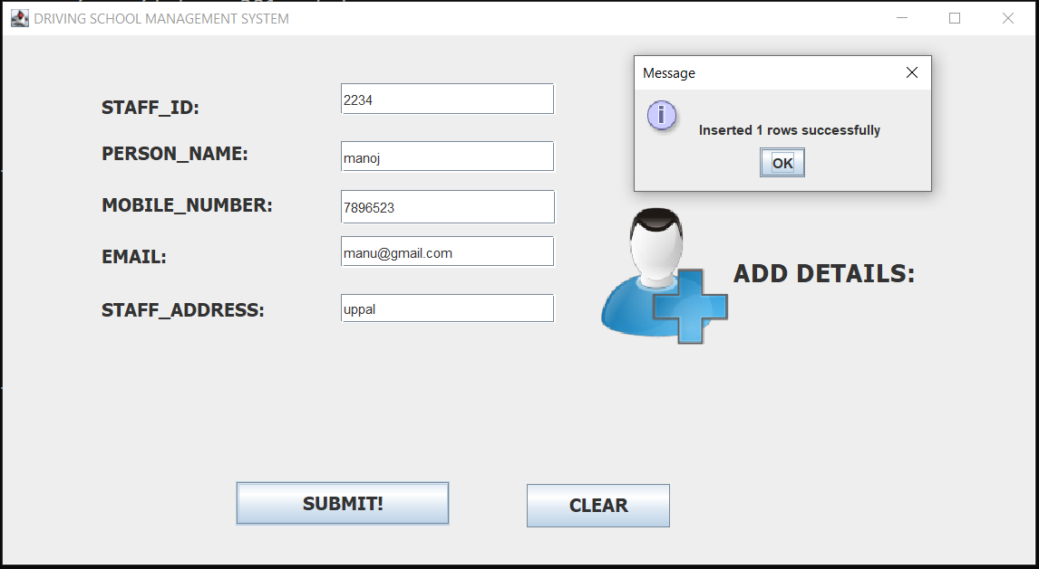

**EDIT STAFF_DETAILS:**

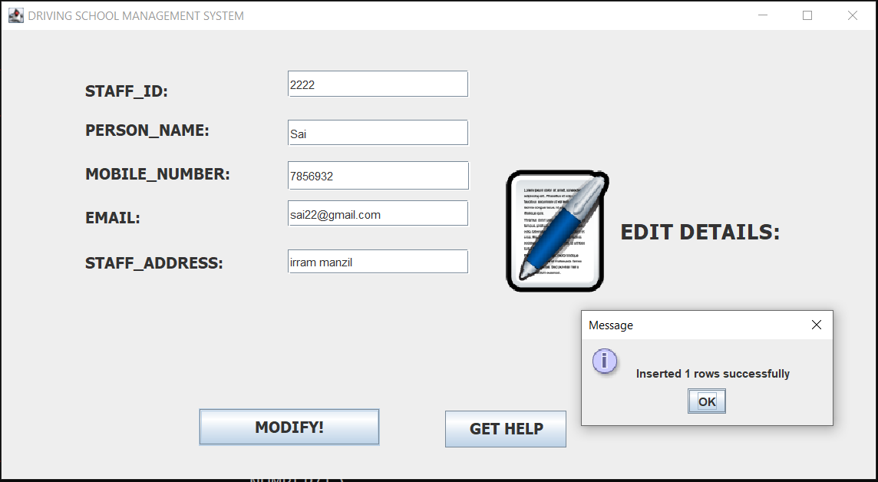

**DELETE STAFF_DETAILS:**

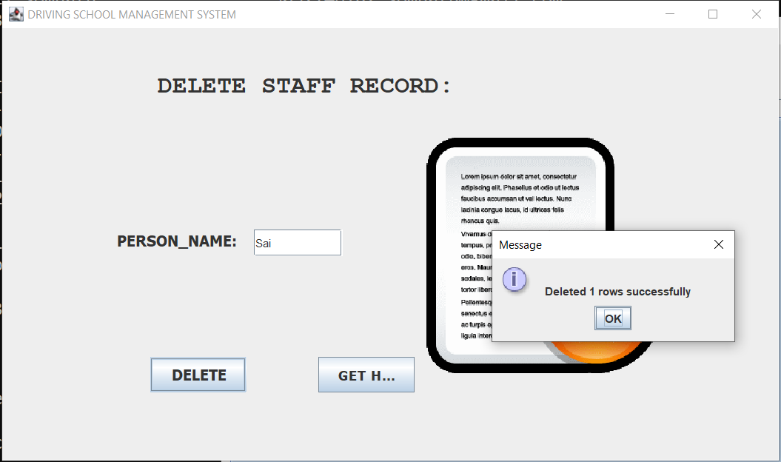

**ON CLICKING GET HELP:**

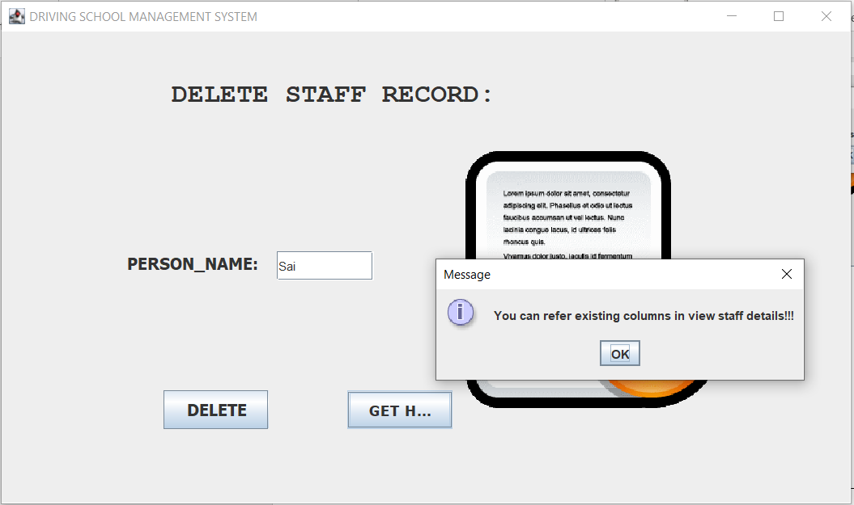

**VIEW STAFF_DETAILS:**

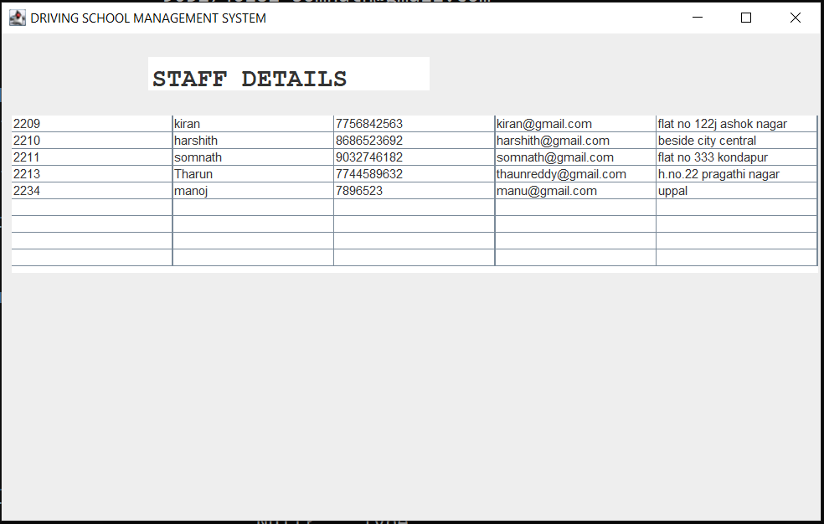

**ID PROOFS&POSTAL:**

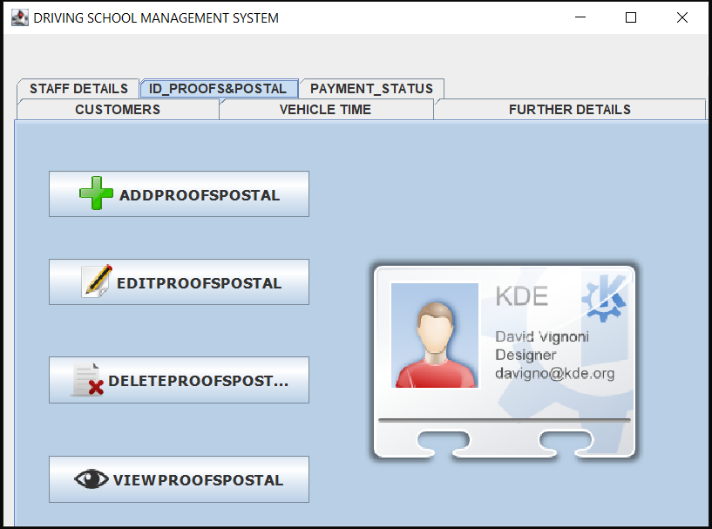

**ADD PROOSPOSTAL:**

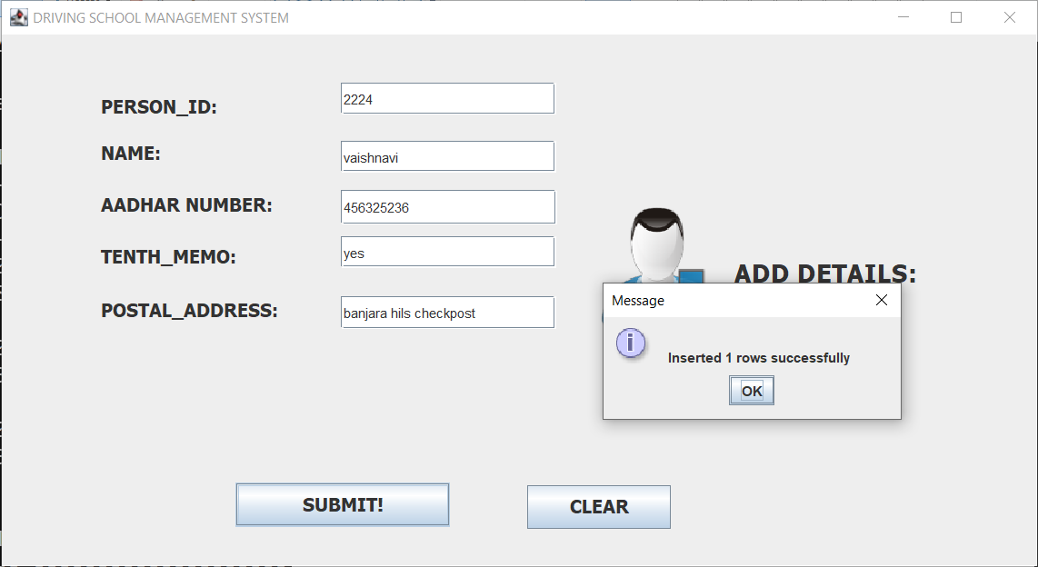

**EDITPROOFSPOSTAL:**

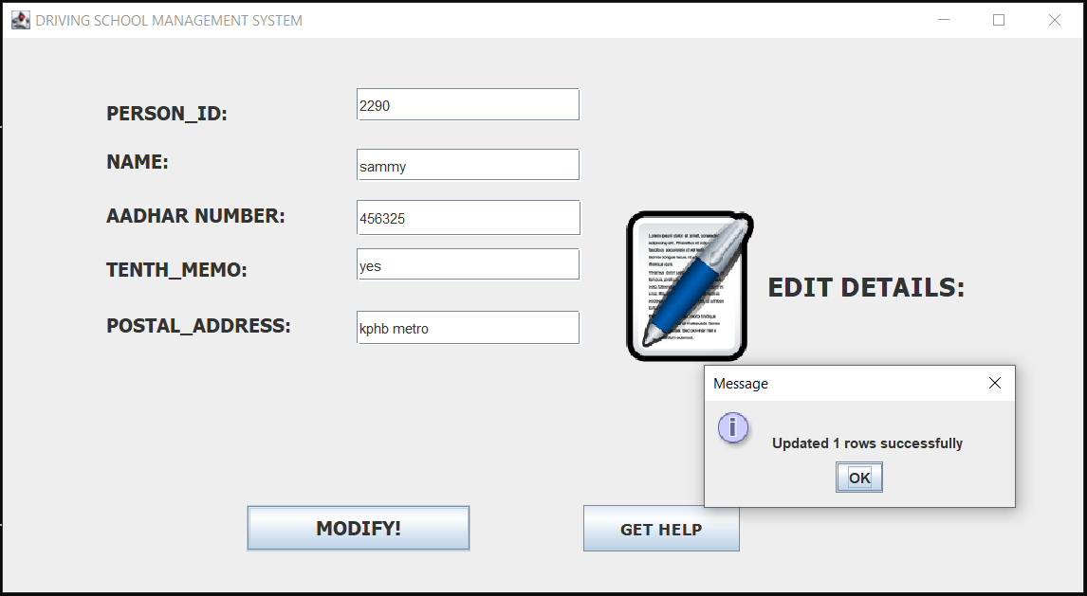

**DELETEPROOFSPOSTAL:**

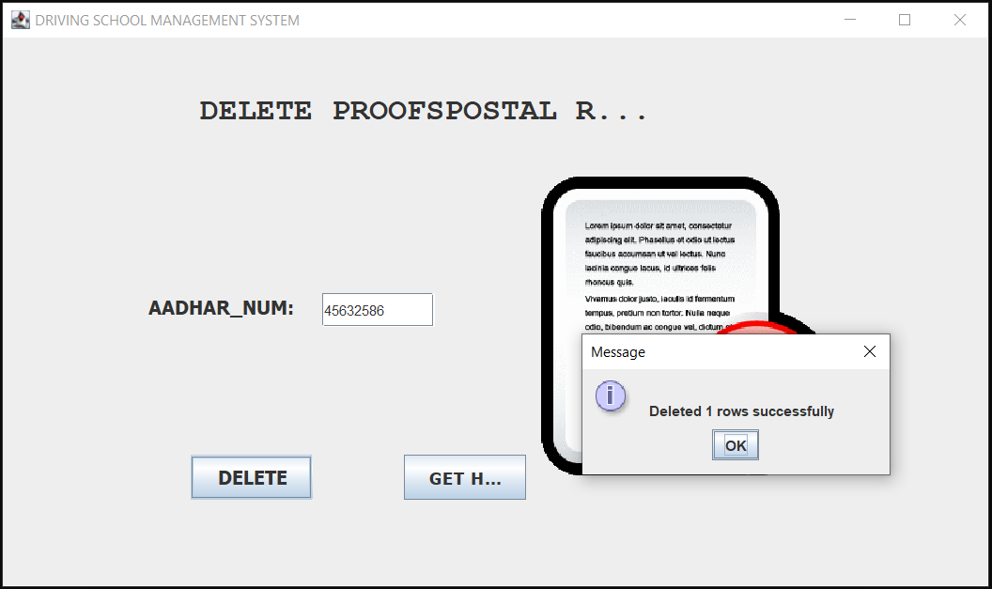

**VIEW PROOFSPOSTAL:**

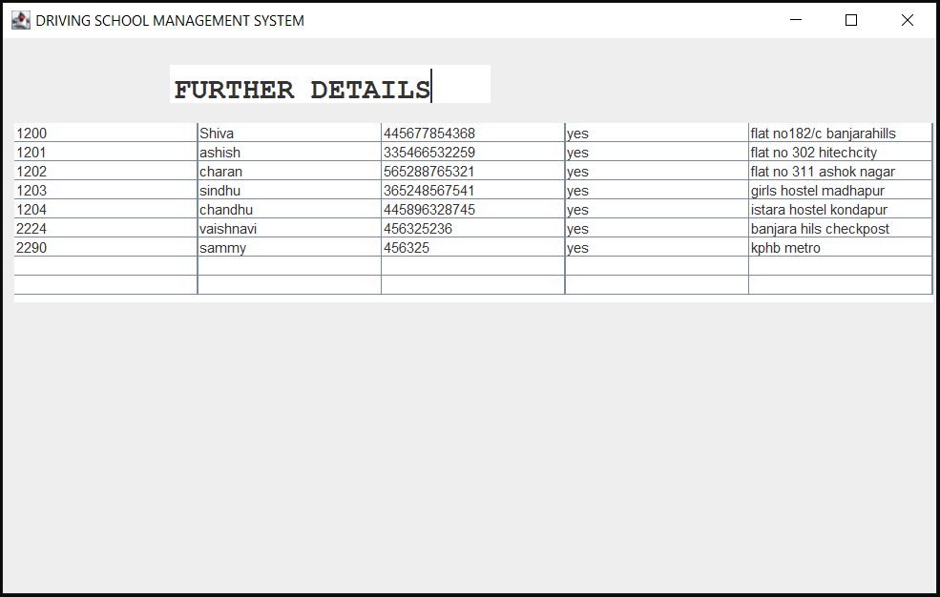

**PAYMENT_STATUS:**

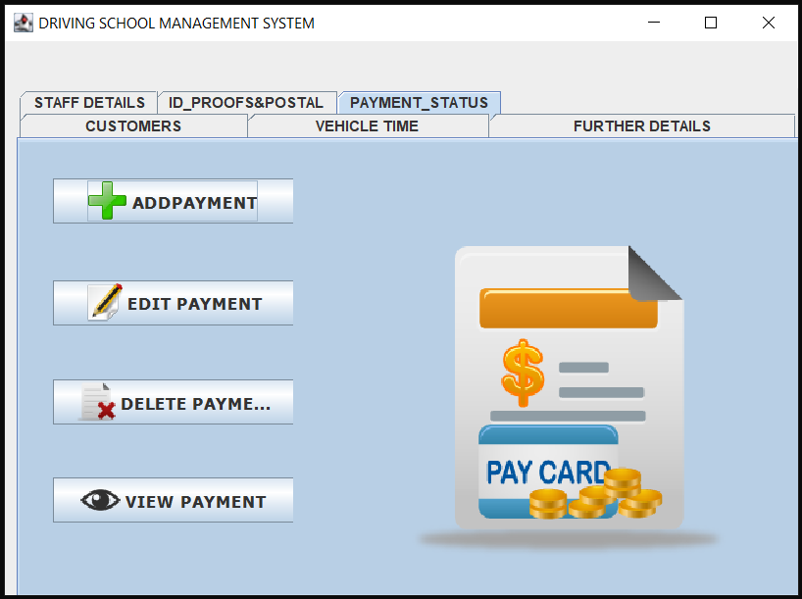

**ADDPAYMENT:**

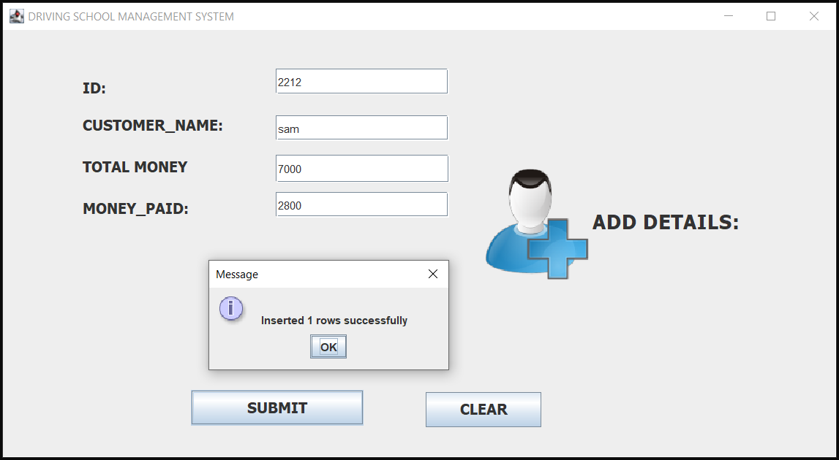

**EDITPAYMENT:**

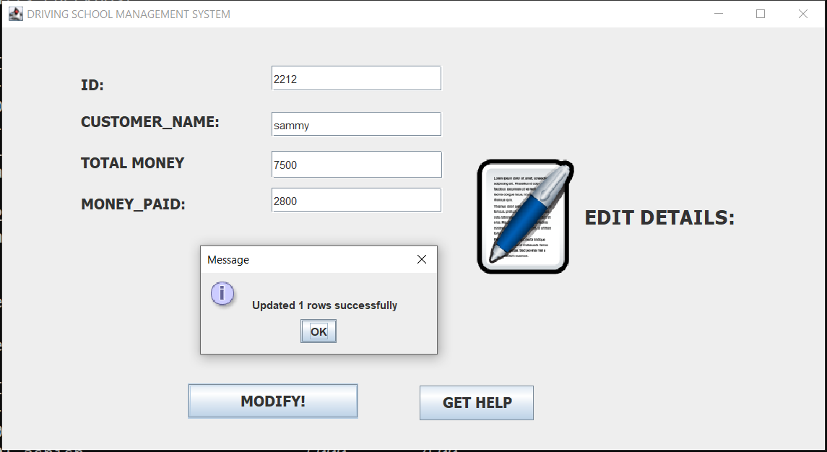

**DELETEPAYMENT:**

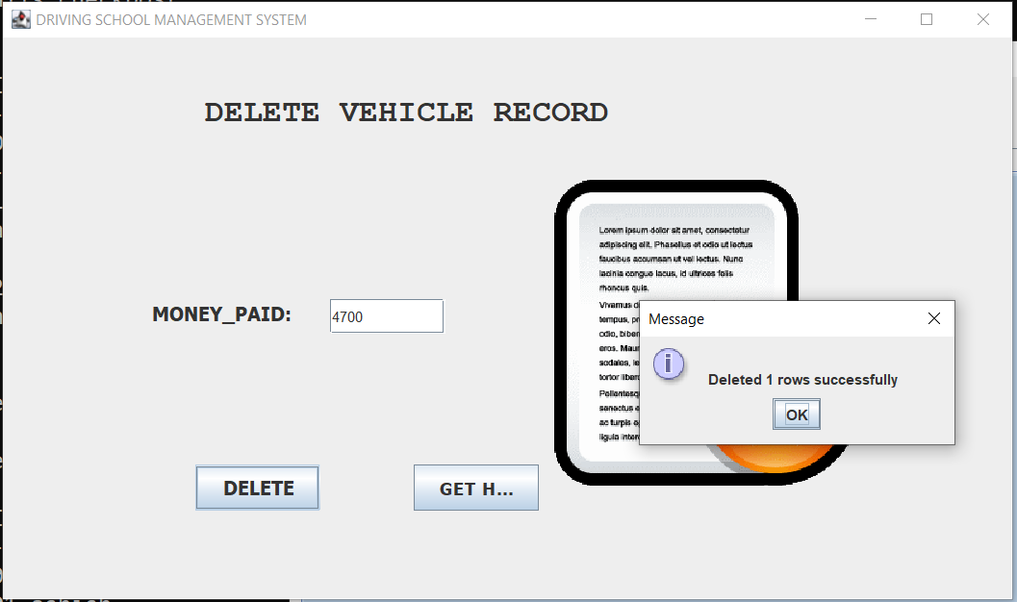

**VIEWPAYMENT:**

